DEMAND FORECASTING AND INVENTORY OPTIMIZATION FOR FOOD RETAILERS
Project Report submitted in the partial fulfilment
of
Bachelor of Technology
in
Information Technology
Submitted To

SVKM’s NMIMS,
Mukesh Patel School of Technology Management & Engineering,
Shirpur Campus (M.H.)
Submitted By:
Yatin Patil Enrollment No – 70012300043
Soumy Raghuvanshi Enrollment No – 70012300116
Chinmay Patil Enrollment No – 70012300123
Under The Supervision Of:
Dr. Srikanth Pulipeti
(Head Of Department, Information Technology Department, MPSTME)

INFORMATION TECHNOLOGY DEPARTMENT
Mukesh Patel School of Technology Management & Engineering
ACADEMIC SESSION: 2026-27
CERTIFICATE

This is to certify that the project entitled “Demand Forecasting and Inventory Optimization for Food Retailers” has been done by
“Yatin Patil” (SAP ID : 70012300043)
“Soumy Raghuvanshi” (SAP ID : 70012300116)
“Chinmay Patil” (SAP ID : 70012300123)
under my guidance and supervision & has been submitted partial fulfilment of the degree of “Bachelor of Technology in Information Technology” of MPSTME, SVKM’S NMIMS (Deemed-to-be University), Shirpur (M.H.), India.
____________ ___________
Project Mentor Examiner
(Internal Guide)
Date:

Place: Shirpur ___________
H.O.D.

INFORMATION TECHNOLOGY DEPARTMENT
Mukesh Patel School of Technology Management & Engineering

ACKNOWLEDGEMENT
After the completion of this capstone Project work, words are not enough to express my feelings about all those who helped me to reach my goal; feeling above this is my indebtedness to The Almighty for providing me this moment in life.
It’s a great pleasure and moment of immense satisfaction for me to express my profound gratitude to Dr. Srikanth Pulipeti, Head Of Department, Information Technology Department, MPSTME, Shirpur, whose constant encouragement enabled me to work enthusiastically. Their perpetual motivation, patience and excellent expertise in discussion during progress of the project work have benefited me to an extent, which is beyond expression. Their depth and breadth of knowledge of Information Technology field made me realize that theoretical knowledge always helps to develop efficient operational software, which is a blend of all core subjects of the field. I am highly indebted to them for their invaluable guidance and ever-ready support in the successful completion of this project in time. Working under their guidance has been a fruitful and unforgettable experience.
We express my sincere thanks and gratitude to Dr. Srikanth Pulipeti, Head of Department, Information Technology Department, MPSTME, Shirpur, for providing necessary infrastructure and help to complete the project work successfully.
We also extend my deepest gratitude to Dr. Venkatadri Marriboyina, Associate Dean, SVKM’S NMIMS, Shirpur Campus for providing all the necessary facilities and true encouraging environment to bring out the best of my endeavors.
We sincerely wish to express my grateful thanks to all members of the staff of Information Technology department and all those who have embedded me with technical knowledge of computer technology during various stages of B.Tech. Information Technology.
We would like to acknowledge all my friends, who have contributed directly or indirectly in this capstone Project work.
The successful completion of a capstone Project is generally not an individual effort. It is an outcome of the cumulative effort of a number of persons, each having their own importance to the objective. This section is a vote of thanks and gratitude towards all those persons who have directly or indirectly contributed in their own special way towards the completion of this project.

Yatin Patil
Soumy Raghuvanshi
Chinmay Patil

ABSTRACT
Perishable food retailers face a harsh operational reality: they have a very short window for sale of their food products (from 12 to 24 hours), and any unsold stock is a total loss and any failed sale is lost revenue and lost customers. Small and medium sized enterprise (SME) retailers don't have enterprise resource planning (ERP), and they mostly use manual intuition, which results in chronic inventory waste. A Capstone Project that presents an end-to-end demand forecasting and perishable inventory decision-support platform that is specifically designed for independent food retailers, to optimize the daily replenishment process and to reduce food waste.
The platform created separates the scheduled cloud execution from offline research benchmark. A lightweight automated batch engine computes the daily needs forecast and baseline safety buffers every night for practical use. Empirical research is conducted across 38 weekly rolling origins from historical sales data of an artisan food retailer, with a rigorous evaluation of the different time-series and machine learning models. Classical additive models are able to capture wide variety of weekly and annual seasonality, but models based on gradient boosted decision tree and using day-ahead point-of-sale telemetry data outperform other models in terms of predictive performance, proving that the most important factor affecting short-term sales is the sales momentum of the past few days. However, experimental tests of external weather regressors suggest that local weather variables are not useful for forecasting and so should not be included in the operational system.
The platform combines demand forecasts with an asymmetric Newsvendor ordering policy that provides a trade-off between gross margin per unit and overstocking costs for making production decisions. This economic policy significantly reduces the amount of food waste that is generated in the physical world while improving the overall profit for the business, compared to the rigid high-service buffering heuristics, in multi-month simulated backtests of a retail catalog of products. The entire solution is a full stack software solution with a RESTful containerized backend, cloud database persistence, and a cross-platform mobile client that also includes an AI assistant that provides instant plain language executive briefings and inventory risk alerts, which store managers don't need to interpret.
Keywords: Demand Forecasting, Perishable Food Retail, Newsvendor Problem, Time Series Analysis, Gradient Boosted Trees, Inventory Optimization, Cloud Architecture.

TABLE OF CONTENTS
Topics | Page
List of Figures | ix
List of Tables | x
Abbreviations | xi
Chapter 1 INTRODUCTION
1.1 Background of the project topic | 1
1.2 Motivation and scope of the report | 2
1.3 Problem statement | 3
1.4 Salient contribution | 4
1.5 Organization of report | 5
Chapter 2 LITERATURE SURVEY
2.1 Introduction to overall topic | 7
2.2 Exhaustive literature survey | 10
Chapter 3 METHODOLOGY AND IMPLEMENTATION
3.1 Block diagram | 14
3.2 Hardware description | 16
3.3 Software description, flowchart / algorithm | 16
Chapter 4 RESULTS AND ANALYSIS
4.1 Master 38-Fold Accuracy Benchmark and Deployed Engine | 27
4.2 Summer Peak Stress Test Performance | 29
4.3 Inventory Simulation Economics and Service Level Frontier | 30
4.4 Weather Evaluation and Placebo Null Distribution | 32
4.5 Software Quality Assurance and Master Defect Register | 33
4.6 Deployment Verification and Physical Mobile Walkthrough | 36
Chapter 5 ADVANTAGES, LIMITATIONS AND APPLICATIONS
5.1 Advantages | 38
5.2 Limitations | 39
5.3 Applications | 40
CONCLUSION AND FUTURE SCOPE | 41
References | 43
Appendix A: Sample code | 45
Appendix B: Data sheets | 46
Appendix C: List of components | 47
Appendix D: List of papers presented and published | 47

LIST OF FIGURES
Sr. No. | Figure No. | Name of Figures | Page
1 | Fig. 1.1 | Historical Daily Sales Trajectory and Baseline Demand Forecast | 4
2 | Fig. 3.1 | End-to-End System Architecture and Data Ingestion Flow | 14
3 | Fig. 3.2 | UML Use Case Diagram: Retail Roles and Operations | 22
4 | Fig. 3.3 | UML Class Diagram: Domain Entities and State Providers | 23
5 | Fig. 3.4 | UML Sequence Diagram: Batch Forecast and Intraday Check-In | 24
6 | Fig. 3.5 | UML Activity Diagram: Restocking Decision Workflow | 25
7 | Fig. 3.6 | Entity-Relationship (ER) Diagram: Cloud Database Collections | 26
8 | Fig. 4.1 | Master 38-Fold Forecasting Accuracy Benchmark across Rolling Origins | 28
9 | Fig. 4.2 | Profit vs Spoilage Waste Frontier under Varying Safety Buffers | 31
10 | Fig. 4.3 | Weather Placebo Null Distribution and Circular Shift Permutation Test | 33
11 | Fig. 4.4 | Mobile Application Screens: Login, Dashboard, Alerts, Check-In, Assistant | 37

LIST OF TABLES
Sr. No. | Table No. | Name of Table | Page
1 | Table 2.1 | Comparative Analysis of Demand Forecasting and Inventory Models | 11
2 | Table 3.1 | Hardware Environment Specifications | 16
3 | Table 3.2 | System Architecture Component Execution and Status Matrix | 15
4 | Table 3.3 | Master POS Dataset Summary Statistics (Guérande Artisan Bakery) | 17
5 | Table 3.4 | Primary SKU Inventory Catalog and Baseline Parameters | 17
6 | Table 3.5 | FastAPI Production REST Endpoints Specification | 20
7 | Table 4.1 | Master 38-Fold Accuracy Benchmark (Weekly Rolling Origins) | 27
8 | Table 4.1b | Deployed Batch Engine Accuracy Evaluation (Production Logic) | 29
9 | Table 4.2 | Summer Peak Stress Test Performance Matrix (6 Rolling Folds) | 29
10 | Table 4.3 | End-to-End Inventory Simulation Economics (88 Days, 35 SKUs) | 31
11 | Table 4.4 | Inventory Policy Optimization Gains (vs Zero Buffer & 95% Service Level) | 31
12 | Table 4.5 | Master Production Defect Log & Post-Mortem Register (DEF-001 to DEF-013) | 34

ABBREVIATIONS
Abbr. | Full Expansion | Abbr. | Full Expansion
API | Application Programming Interface | MAPE | Mean Absolute Percentage Error
ARIMA | Autoregressive Integrated Moving Average | ML | Machine Learning
BVA | Boundary Value Analysis | MSME | Micro, Small & Medium Enterprises
CI | Confidence Interval / Continuous Int. | OWASP | Open Web Application Security
CD | Continuous Deployment | POS | Point of Sale
COGS | Cost of Goods Sold | RAG | Retrieval-Augmented Generation
CORS | Cross-Origin Resource Sharing | RAM | Random Access Memory
CR | Critical Ratio | REST | Representational State Transfer
DTO | Data Transfer Object | RMSE | Root Mean Squared Error
EFB | Exclusive Feature Bundling | SARIMA | Seasonal Autoregressive Int. Moving Avg.
EPP | Equivalence Partitioning | SKU | Stock Keeping Unit
ERP | Enterprise Resource Planning | SME | Small and Medium Enterprises
FMCG | Fast-Moving Consumer Goods | SQL | Structured Query Language
GAM | Generalized Additive Model | TFT | Temporal Fusion Transformer
GBDT | Gradient Boosted Decision Trees | TSB | Teunter-Syntetos-Babai
GOSS | Gradient-Based One-Side Sampling | UAT | User Acceptance Testing
HGBR | HistGradientBoostingRegressor | UI / UX | User Interface / User Experience
JWT | JSON Web Token | UML | Unified Modeling Language
LLM | Large Language Model | UTC | Coordinated Universal Time
MAE | Mean Absolute Error | WAPE | Weighted Absolute Percentage Error

Contents
INTRODUCTION 1

Chapter 1

INTRODUCTION
This chapter presents the operational difficulties, economic relevance and research inspiration behind the proposed intelligent demand forecasting and perishable inventory replenishment decision-support platform designed for small and medium food retail businesses. This project topic was introduced in Section 1.1 and explained in the background. The operational motivation and practical boundaries of the scope are stated in section 1.2. In Section 1.3, you will formalize the mathematical problem statement. The highlights of the project are given in Section 1.4, the technology stack and implementation environment are detailed in Section 1.5, and the outline of this Capstone Project report is outlined in Section 1.6.
1.1 Background of the project topic
Perishable food retail, including artisan bakeries and patisseries, specialty deli-cafes, and fresh food cafes, is a critical element of neighborhood commerce and urban food systems. Apparel, consumer electronics, or shelf-stable packaged food products are not as severely degraded by biological processes as fresh food products are, and do not have such a short commercial shelf life. Starch retrogradation and moisture redistribution cause artisan breads and traditional crusty baguettes to quickly become inedible, and cause crusts to lose crispness, which makes unsold bread unsoldable within 12 to 24 hours of being baked in the morning.
Under this strict perishability requirement, store managers are faced on a daily basis with a dilemma of optimization: over-baking results directly in a loss of valuable raw materials (unbleached flour, cultured butter (European), dairy products and yeast), and skilled artisan labor. On the other hand, over-baking results in early sell-outs in the afternoon, which results in lost gross margins and lost customers to other vendors who are close by. On top of this operational nuisance, the demand of the customers is strongly seasonal and influenced by day-of-week consumption trends, local public holidays, school vacations and by acute macro-seasonal spurts in tourist flows.
In conventional independent bakeries, stock replenishment is largely based on the instinctive judgment of the individual, on the manual memory of the staff or on a fixed and unchanging pen and paper ledger. All of these informal heuristics have a limited ability to add up multi-seasonal cyclicality, localized trend shifts and inter-product demand cannibalization. In the case of artisan food retail, the amount of food waste can be as high as 15% to 30% of daily production, which is an economically unsustainable burden on independent retail margins, and a failure in urban resource planning.
1.2 Motivation and scope of the report
Supermarket giants and consumers goods chains are backed by sophisticated enterprise forecasting systems with dedicated analytics departments, whereas, independent micro and small food retailers are not. The analysis of the retail operations leads to four major gaps in the operations that inspire the design of the proposed platform:
1. The Forecast-to-Action Decision Gap: The standard machine learning pipelines that are created and trained for demand forecasting end at the point of predicting that 45 baguettes will be sold, and the store manager has no indication on how many units to actually produce. Since customers are stochastic, baking the point forecast leads to a guarantee of 50% getting stocked when errors are symmetric. The global mean strategy is not optimal for a perishable food retail business, because the gross margin on a sold good is greater than the loss of the unsold good.
2. Multi-day schedules are frequently produced by weekly batch forecasting systems that are based on outdated weekly lags that fail to consider the immediate previous day's trading volume (lag_1), which is also important for predicting. There is a need for a system, which connects weekly planning with day-ahead telemetry, to provide a marked enhancement in the responsiveness of the operation.
3. The Compute and Accessibility Barrier: Enterprise forecasting platforms require large clusters of computers, special database engineers and complicated operational dashboards. Artisan food retailers need zero-overhead mobile apps that work on inexpensive commodity smartphones with cloud-based backends that perform well and remain highly available on cost-effective cloud tiers.
4. Traditional Waste Mitigation Gap: Inventory management, morning production planning and evening waste mitigation are treated as separate processes. Before a store's perishables are completely obsolete, they need automated and deterministic decision rules that alert them to mark them down for the day based on the foot traffic at a specific point in time, as well as alert them to donate money to a charity through specific tiers of discount (20% or 30%). Academic rigor and engineering feasibility are considered within a Capstone time frame, thus defining the scope boundaries of the project as follows :
- In-Scope: Daily granular demand forecasting for primary and sparse bakery products; rolling out-of-sample backtesting for 38 weekly horizons using an empirical benchmark evaluation; empirical validation using 637-day real-world POS transaction data; day-ahead stochastic replenishment ordering policy using the single-period Newsvendor approach; intraday waste alert generation comparing physical inventory pace against anticipated daily sales; dynamic markdown discounting workflow (20% and 30% discount tiers) and food donation flagging; containerized FastAPI REST backend deployed on cloud infrastructure; and a cross-platform mobile client for store managers developed using the Flutter framework.
- Out-of-Scope: Direct hardware automation of physical bakery deck ovens; integration with proprietary physical point-of-sale barcode scanner peripherals; multi-echelon cold-chain distribution logistics; and automated financial accounting ledger synchronization.

1.3 Problem statement
The problem the project is trying to solve is as follows: Given a set of N perishable SKUs (stock-keeping units) for an artisan food retailer in daily trading intervals $t = 1,$ 2, ..., T, design an end-to-end operational software platform that:
- Accurate Daily Demand Estimation: Accurately estimates daily customer demand $\hat{y}\left(i, t\right)$for each SKU i at each trading origin t by effectively separating from the strong day-of-week seasonality, annual calendar holidays and macro-seasonal tourists surges with a minimum out-of-sample Weighted Absolute Percentage Error (WAPE).
- Economically Optimal Replenishment Buffers: Given stochastic point forecasts ŷ(i, t) and error standard deviations $σ̂(i, t),$ translates these into an economically optimal production order quantity $Q*(i, t)$ that maximizes the expected net trading profit under asymmetric underage (lost gross margin) and overage (wasted cost of goods sold) costs cᵤ and cₒ.
- Continuously track intraday sales volume compared to anticipated consumption and automatically provide timely actionable markdown recommendations and charity donation alerts before closing at the end of the day.
- Mobile & Cloud Delivery: Production recommendations sent to store operators via a responsive, low latency mobile app seamlessly connected to multi-tenant cloud persistence and natural language executive briefing. 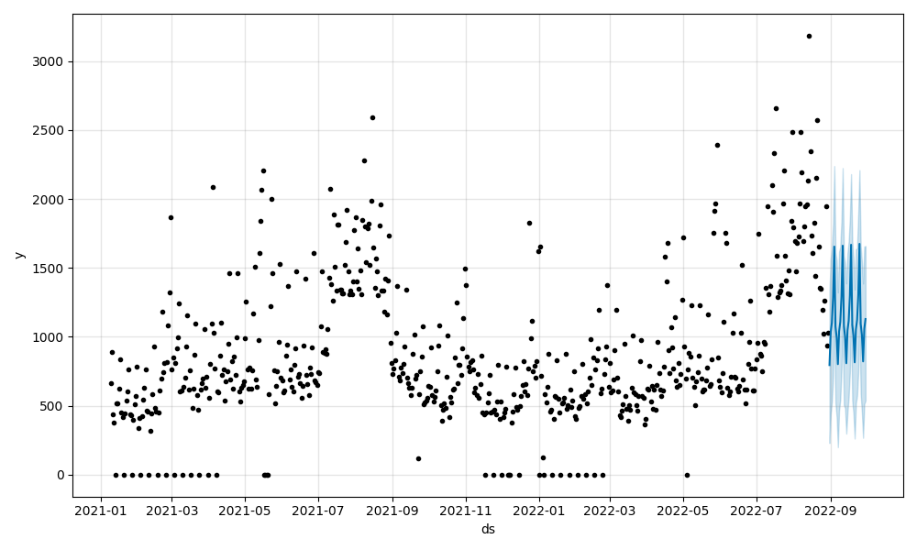
Fig1. 1 History
Fig. 1.1: Historical Daily Sales Trajectory and Baseline Demand Forecast
1.4 Salient contribution
This Capstone Project delivers four precise empirical, mathematical, and software engineering contributions:
- 1. Empirical Discovery of Day-Ahead Telemetry Superiority (Control 3): We run an exhaustive backtest over 38 weeks using the weekly rolling origin to perform over 637 days of real-world French bakery sales from point-of-sale, and show that Control 3 (which combines 1-day lag telemetry y(t−1) with a single-stage HistGradientBoostingRegressor) improves the pooled WAPE by +2.47 percentage points (27/38 fold wins; paired cluster bootstrap CI [+0.49, +4.76] exact sign-test p = 0.0138) over the Prophet baseline (+27.95). This defines the use of the point-of-sale telemetry synchronization as the biggest predictive accuracy lever to be implemented with next generation (V2) deployment.
- 2. Rigorous Evaluation of Prophet + HGBR Research Hybrid Model: We propose a feature-stacked hybrid research model, by combining the Prophet trend and seasonality components and a pooled HistGradientBoostingRegressor for evaluation. The weekly wins for the hybrid are 19/38, or about 50%, and Prophet is 27.95% in the same time span, resulting in probabilistic equality (95% CI [−0.91, +0.29]). The hybrid performs significantly better than classical heuristics over the course of the season such as Seasonal Naive (30.39%), 7-Day Moving Average (30.70%), and 4-Week Same-Weekday Average (39.31%) during extreme summer peak stress testing (6 rolling folds from 16 July to 30 September 2022).
- 3. Methodological Rejection of Weather Regressors via Placebo Testing: A rolling-origin benchmark approach and a placebo test with 200 iterations of circular-shift are used to evaluate exogenous weather regressors (temperature anomaly, precipitation, sunshine hours). The average of the placebo models was a negative shift of −0.51 percentage points from baseline, while the real weather model (+0.32 percentage points) was greater than the placebo models, suggesting that the shift test is unable to separate the underlying seasonality from weather signals. Rejection of the weather features is instead based on a non-informative paired bootstrap confidence interval that includes 0 (CI [−0.24, +0.87]) and a 24/38 win rate that is less convincing, and a 2.15 percentage point behind Control 3.
- 4. Stochastic Inventory Optimization and Full-Stack Cloud Deployment: We use an asymmetric Newsvendor Critical Ratio ordering policy, which is the combination of demand forecasts and COGS (40% COGS, z = +0.2533, CR = 0.60). The net profit for Control 3 under the policy is €41,635.90 (12.7% waste) and for the research hybrid is €40,571.43 (11.2% waste), representing an actual reduction of physical food waste of 64.4% (−16,243 units) and 64.0% (−13,353 units) respectively when compared to a rigid 95% cycle service level buffer across 35 SKUs (68,883 total actual food demanded). The full solution is achieved using containerized FastAPI services, MongoDB Atlas persistence, and a cross-platform Flutter mobile client with verifiable Google Gemini briefings (validated with 44 automated Flutter tests, 7 FastAPI/service tests, and a 13 item defect log).

1.5 Technology Stack and Implementation Environment
The proposed solution decision-support platform is implemented using a modern, decoupled, cloud-to-mobile architecture designed for low operational overhead and high computational reproducibility. The complete system environment comprises five core functional tiers
- Machine Learning Pipeline: Python 3.10, Facebook Prophet 1.1.5 (additive/multiplicative Bayesian time-series decomposition), Scikit-Learn 1.5.2 (HistGradientBoostingRegressor with histogram-based binning), Pandas 2.2.2 and NumPy 1.26.4 (tensor wrangling), and SciPy 1.14.1 (inverse normal cumulative distribution functions for Newsvendor fractiles).
- Backend API & Microservices: FastAPI 0.115.0 (high-performance REST routing in the asynchronous manner), Uvicorn 0.31.0 (ASGI web server), Pydantic v2 (2.10.0 data validation and schema serialization), Motor 3.6.0 (non-blocking MongoDB driver), Passlib 1.7.4 (Bcrypt password hashing), and PyJWT 2.10.1 (cryptographic HMAC-SHA256 access token minting).
- Cloud Persistence & Hosting: MongoDB Atlas, Render Cloud Application Platform (containerized Linux environment with scheduled automatic SSL/TLS termination), and GitHub Actions (scheduled nightly cron runner on ubuntu-latest).
- Mobile Frontend Client: Flutter SDK 3.38.5 and Dart 3.10.4, implementing Provider 6.1.2 for reactive domain state management, Material Design 3 design tokens, touch-ergonomic input clamping, and resilient HTTP client retry channels.
- With zero-math structured prompt grounding and an integrated local heuristic fallback engine in the mobile client, Generative AI Operational Briefing: Google Gemini API (google-genai 2.29.0 SDK, using gemini-3-flash-preview) enables a personalized briefing experience for each user.
1.6 Organization of report
The remainder of this Capstone Project report is organized into five subsequent chapters:
- Chapter 2: Literature Survey: Analyses the literature on classical time series, generalized additive models, gradient boosted trees, stochastic inventory theory, and retail LLM applications in detail, and finishes it with a comparison of key papers and research needs.
- Chapter 3: Methodology and Implementation: Describes the system architecture, hardware environment, data audit (637 days, 600 open, 37 closures), research vs deployed engine formulations, protocol for evaluation of rolling origins, derivation of Newsvendor, waste rules, backend endpoints, Flutter client, and UML engineering models.
- Chapter 4: Results and Analysis: Includes the empirical results including the master 38-fold accuracy benchmark (Table 4.1), the batch engine evaluation (Table 4.1b), the summer stress test (Table 4.2), these inventory simulation economics (Tables 4.3 and 4.4), the weather placebo analysis, the software testing metrics, defect post mortems (DEF-001, DEF-013, etc.) and the mobile walkthrough screens.
- Chapter 5: Advantages, Limitations, and Applications: Critically analyzes the architectural benefits, recognised empirical and operational constraints, and commercial application.
- Chapter 6: Conclusion and Future Scope: Integrates the key results into a coherent conclusion and outlines the engineering path for further improvements of the V2.
- References and Appendices: Includes 25 verified academic references (IEEE format) and Appendices A through D with source code, data sheets, hardware components and publication disclosures.

Chapter 2

Literature survey
This chapter reviews the literature fully on the developments of mathematical, empirical and architectural works that have contributed to the field of retail demand forecasting, stochastic inventory control, and mobile decision-support systems. Introduces the general topic, serves as a background to the overall topic, and provides a reference to foundational and contemporary literature texts from 25 academic sources. Section 2.2 summarizes the literature extensively and presents a comparative matrix of most of the key studies that outlines the critical research gaps to guide the problem statement of the proposed platform.
2.1 Introduction to overall topic
2.1.1 Classical Statistical Time Series Models
Early literature in the area of commercial inventory forecasting focused mainly on linear statistical models. Foundational research established triple exponential smoothing (Holt-Winters), which decomposes univariate time series into a local level, a linear trend, and multiplicative seasonal factors. Classical formulations formalized Autoregressive Integrated Moving Average (ARIMA) models, which model stationarity using differencing, and estimate linear dependence between the moving average and the autoregressive lags, later extended into seasonal ARIMA (SARIMA) for retail planning. Linear models have a low computational cost, are easy to interpret, but make the assumption of stationary error distributions which may be too restrictive and neglect to capture the inter-SKU cross-correlations which can exist in artisan retail bakeries, as well as non-linear exogenous shocks, and abrupt changes in holiday calendars.
2.1.2 Generalized Additive Seasonality Models (Facebook Prophet)
To tackle the limitations of classical ARIMA for operational business time series, Generalized Additive Models (GAMs) such as Facebook Prophet decompose target demand into a piecewise-linear or logistic trend, a multi-component Fourier series of weekly and yearly seasonalities, a holiday matrix of calendar anomalies, and optional regressors. Applied studies in daily retail demand forecasting have confirmed that explicit calendar and holiday features significantly enhance short-horizon retail sales forecasts. Generalized additive models are very robust to irregular missing observations and structural shifts in the seasonality signal; however, because seasonal components are fitted independently, they lack native mechanisms to capture short-term autoregressive shock persistence (such as day-ahead inventory stockout feedback) or non-linear interactions across product categories.
2.1.3 Gradient Boosted Decision Trees and Ensemble Architectures
Tree-based ensemble learning set a new benchmark for tabular retail demand forecasting. Mathematical formulations of gradient boosting machines demonstrated that fitting shallow regression trees sequentially to the pseudo-residuals of a loss function is an effective way to approximate complex non-linear functions. Production-ready gradient boosting implementations within Scikit-learn, such as HistGradientBoostingRegressor, utilize histogram-based binning similar to LightGBM to speed up the process of building trees from continuous feature values, alongside XGBoost and LightGBM implementations introducing Gradient-Based One-Side Sampling (GOSS) and Exclusive Feature Bundling (EFB).
Large-scale empirical forecasting contests with tens of thousands of retail series have demonstrated that machine learning models that integrate information across series, such as pooled gradient boosted decision trees, significantly outperform pure statistical benchmarks. The natural features of GBDTs include high-dimensional calendar indicators, non-linear lag interactions and cross-sectional pooling across SKUs. However, because tree-based partition models predict constant values outside the range of features observed in training, hybrid models that combine parametric trend modeling with non-linear residual trees provide strong operational appeal.
2.1.4 Deep Neural Architectures for Multi-Horizon Forecasting
Retail demand applications have grown substantially with deep learning architectures. Notable architectures include DeepAR, an autoregressive recurrent neural network that learns probabilistic demand distributions for large collections of related time series, and Temporal Fusion Transformers (TFT), which use self-attention to model long-term temporal information and feature importance to explain the learned information. Comprehensive surveys of retail forecasting practice have observed that while deep sequence models work well in large enterprise applications where there are millions of transactions, they can suffer from severe overfitting, high compute costs, and lack of explainability when applied to small retail stores with short historical records.
2.1.5 Intermittent and Sparse Demand Estimation
Secondary specialty products have irregular demand for these small food retailers and bakeries, with many days of zero sales. Susanto et al. [1] applied time-series and machine learning models to transaction data from small and medium-size enterprises (SMEs), which they found to be discontinuous and dominated by spikes, and showed that conventional machine learning classifiers were not good at handling such distributions unless they were smoothed or explicitly designed for sparsity. Gärtner et al. [2] studied automatic forecasting for small enterprises, finding that classical statistical forecasting techniques become very problematic with few historical samples. To combat this in sparse and cold-start inventory settings, the developed platform combines Croston/TSB demand-interval estimation with credibility shrinkage toward the category 90th-percentile prior ($W = n / (n + 14)$) alongside rolling-average heuristics for cold-start SKUs.
2.1.6 Inventory Optimization and Perishable Waste Reduction
A major finding in the forecasting literature is that a forecasting error metric calculation is not related to operational replenishment decisions. While forecasting with a small error may be enough to prevent a small retailer from experiencing stockouts in the orders, it is not sufficient without an adequate safety buffer, as stated by Rahmatillah et al. [3]. The cost-based inventory simulation demonstrated that a machine learning model that was optimized with dynamic replenishment was able to reduce both stockouts and overstocking when compared to moving average baselines.
Similarly, Munawar and Sudirman [4] determined that by directly reducing lost revenue and food spoilage cost in culinary small and medium enterprises, the forecasting accuracy over short horizon can be directly reduced using cost based simulation model. Padmavathy et al. [5] proposed a set of sustainable constraints, such as waste-aware ones, and combined them with predictive models to show up to a 40% reduction in perishable food waste in sustainable restaurant operations. In food supply chain analytics, Chowdhury et al. [6] validated this claim and demonstrated that data driven demand planning can have a significant impact on reducing food scraps without the need for high cost enterprise infrastructure. Last but not least, Avuduri [7] demonstrated that automated decision support on ubiquitous devices can remove the need for manual tracking of stocks, thus providing a practical model for low cost inventory management for SMEs.
2.1.7 Mobile Applications and Applied AI for Retail SMEs
The use of AI, predictive analytics, and mobile management solutions for micro, small, and medium-sized enterprises (MSMEs) has been explored in recent literature. In our short list of 25 research papers, studies converge on three main operational pillars:
  - SME Demand Forecasting & Machine Learning: Cherian et al. [8] and Gärtner et al. [2] developed automated demand forecasting models for small companies. However, in the case of small food and beverage retail, Aqila [9] found that Facebook Prophet is more stable when the local holiday shocks, and Ganguly [10] and Sandeep et al. [11] found that gradient boosted decision trees are more accurate than classical moving average approaches. The importance of using ensemble machine learning models was confirmed by Jatte et al. [12] and Susanto et al. [1] which concluded that in small retail businesses, it is important to use ensemble machine learning models because they can improve the accuracy of predictions.
  - Food Waste Minimization & Inventory Simulation: Padmavathy et al. [5] explored the use of AI for predictive analytics in the restaurant sector for perishable food waste reduction, while Chowdhury [6] explored the application of AI in supply chains for perishable food waste reduction. Rahmatillah [3] proved that machine learning and dynamic safety stock boundaries can significantly reduce the holding cost and stockout that happen in SMEs ice-cream retail, and Avuduri [7] used automated real-time inventory management simulation system for a small warehouse and stockroom to considerably reduce the spoilage.
  - Mobile Decision Platforms & Conversational AI: Janchidfah et al. [13] developed a special mobile application for small business stock management, where there are no overhead interfaces and restock warnings for small business owners. To integrate conversational GPT-4 into shop management, Sakuda et al. [14] proposed using this model to oversee the store conversation. Vyakarnam et al. [15] showed the most effective approach for complementary supply chain investigations was to not include any arithmetic operations in the model and only have it summarize qualitative narrative information. Finally, Groene [16] and Yuniarty et al. [17] and Aree and Ueasangkomsat [18] found that operational simplicity, zero arithmetic overhead and proven economic gain are prerequisites for technology to be adopted which are important for independent retail managers.
2.2 Exhaustive literature survey
To synthesize the theoretical and empirical literature, Table 2.1 presents a structured comparative analysis of 12 core studies spanning statistical forecasting, machine learning ensembles, stochastic inventory theory, and applied SME retail architectures:
Table 2.1: Comparative Analysis of Demand Forecasting and Inventory Models
Study & Authors | Domain & Context | Methodology & Model | Key Empirical Findings | Identified Research Gap
Groene & Zakharov (2024) [16] | F&B Retail Outlets | XGBoost with Weather & Holidays | Achieved 33% RMSE reduction over manual manager planning. | Forecast-only; lacks inventory restocking guidance.
Rahmatillah et al. (2026) [3] | SME Ice Cream Retail | Optimized LSTM vs. Moving Average | Simulation proved ML forecasts cut stockouts and holding costs. | Requires substantial historical data depth; no mobile tool.
Güler et al. (2024) [19] | Restaurant Daily Sales | Facebook Prophet with Weather/Events | Accurately captured holiday surges and trends (MAE: 0.76). | Single-site focus; lacks real-time mobile restocking logic.
Lalitha et al. (2025) [20] | Perishable Food Retail | Random Forest with Weather Regressors | Built dynamic pricing engine responsive to short-term weather shifts. | Dependent on real-time data feeds; lacks simple mobile interface.
Susanto et al. (2026) [1] | SME Pre-Orders | Time-Series & Tree Classifiers | Simple moving average proved competitive on zero-inflated sales. | GBDT struggles on discontinuous, spike-dominated demand.
Munawar & Sudirman (2026) [4] | SME Culinary Retail | LSTM Hourly Sales Model | Hourly demand capture reduced spoilage and lost revenue in simulation. | Excludes external weather regressors; computationally heavy.
Aqila et al. (2026) [9] | Coffee Shop SME | SARIMA vs. Prophet vs. LSTM | Prophet demonstrated superior operational stability under holiday shocks. | Evaluated only on error metrics; no replenishment policy.
Gärtner et al. (2024) [2] | SME Cross-Sector | Automated ML vs. Classical Models | Machine learning models outperformed classical statistical baselines. | Severe performance drop under small cold-start training windows.
Kamboj et al. (2025) [21] | Drugstore Chain Retail | Hybrid Prophet + XGBoost | Reduced median MAPE by 18% over pure baseline models. | High technical overhead; lacks automated waste alert tiers.
Jatte et al. (2025) [12] | Retail Supermarket | Comparative AI Framework | Prophet reached 85.7% accuracy with significantly lower compute than LSTM. | Focused on enterprise scale; lacks edge mobile application.
Padmavathy et al. (2025) [5] | Restaurant Operations | AID-PAF Waste-Aware Model | Predictive replenishment demonstrated up to 40% reduction in food waste. | High hardware and compute demands incompatible with micro-SMEs.
Janchidfah et al. (2026) [13] | Retail MSME | Mobile Inventory Application | Intuitive mobile design achieved high adoption among non-technical owners. | Basic inventory tracking only; lacks predictive ML forecasting.
Proposed Platform | Artisan Food Retail | Feature-Stacked Prophet + GBDT & Mobile UI | Outperformed heuristics on summer stress test; cut simulated waste by 64%. | Bridges the forecast-to-action gap on commodity smartphones.

2.2.1 Synthesis of Research Gaps
A critical synthesis of the literature reveals four persistent research and engineering gaps:
- 1. The Disconnection between ML Point Forecasts and Asymmetric Inventory Optimization: The majority of the existing literature considers the assessment of the demand forecasting models by symmetric measures of loss (RMSE, MAE, WAPE) [16], [9], [2]. The cost of perishable food stockout in retail locations, however, is much greater than the cost of discards. Most of the studies examined do not go beyond assessing the point forecasts for errors and adjust them to replenishment orders that directly enhance the profitability of business and decrease the waste [3], [4].
- 2. The Under-Explored Power of Day-Ahead Telemetry vs Weekly Batch Horizons: Multi-stage hybrid models (such as Prophet + GBDT) are frequently evaluated for multi-day or multi-week retail forecasting horizons [21]. In artisan food settings, however, the impact of using 1-day lag telemetry (lag 1 sales volume) in an environment not free of calendar models has not been rigorously ablated against multi-stage residual architectures [16].
- 3. Uncritical Acceptance of Exogenous Weather Features without Rigorous Placebo Verification: Exogenous meteorological variables (temperature, rainfall, sunshine) are frequently integrated into food demand models [19], [20], [22], [23]. Weather, however, is heavily collinear with underlying macro-annual seasonality (e.g., warm weather coinciding with summer tourism). In the literature, circular-shift permutation placebo tests are rarely performed, allowing spurious seasonal correlations to be mistakenly interpreted as daily weather sensitivity.
- 4. The Absence of End-to-End, Zero-Overhead Mobile Decision Platforms for Independent Retailers: Enterprise ERP solutions are suited to large supermarket operators, while models developed for e-commerce or specialized SME audits [24], [25] rarely translate to low-margin storefronts. Independent artisans require easy-to-use, cloud-based mobile apps that provide daily restocking check-ins, automated intraday waste markdown alerts, and deterministic executive summaries without technical overhead [13].
The classical and modern demand forecasting methods and approaches, stochastic inventory concepts, and architectures for mobile retail systems have been discussed in this chapter, and four key operational gaps were identified. Chapter 3 discusses the system Architecture, Data set Audit, Mathematical Formulations and Engineering Implementations proposed to address these gaps of the proposed system.
Chapter 3
Methodology and Implementation
This chapter provides in-depth engineering methodology, system architecture, mathematical formulations and software implementation of the proposed demand forecasting and inventory replenishment platform. The first two sections, namely, Section 3.1: System Block Diagram and Section 3.2: Component Execution Matrix, are presented. Section 3.2 defines the hardware and compute environment in development, mobile client and persistence tiers on cloud. The software description, POS dataset calendar audit, research versus deployed forecasting pipelines, rolling origin evaluation protocol, stochastic Newsvendor replenishment derivation, intraday waste classification rules, cloud backend security architecture and mobile client design are provided in Section 3.3.
3.1 Block diagram
The proposed platform is designed to be a multi-layered, decoupled, cloud-to-mobile solution to connect offline predictive machine learning with real-time operational decision support for independently owned food retailers. The system architecture ensures data is ingested, the time-series decomposed with statistics, non-linear machine learning, stochastic inventory optimization, and briefing with natural-language.
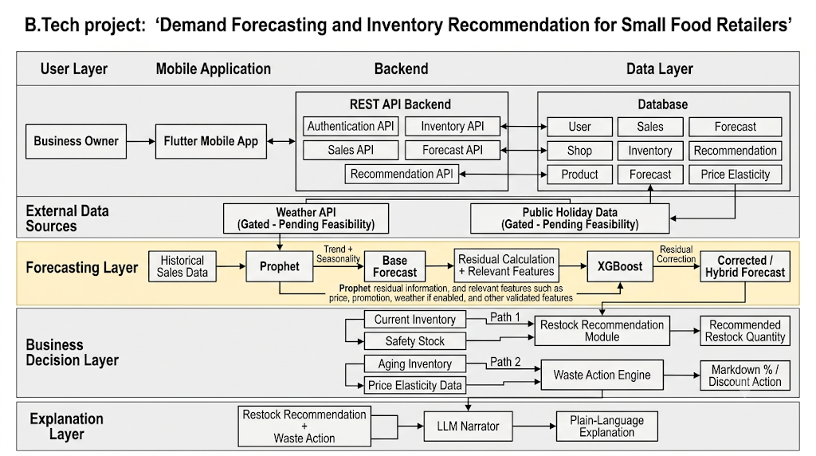
Fig. 3.1: System Architecture and Operational Block Diagram
As delineated in Fig. 3.1, the operational architecture functions across six integrated layers:
1. User Layer: The primary operator of the platform is the retail store manager or business owner, who interacts with the system through commodity handheld mobile hardware during morning restocking and afternoon inventory audits.
2. Mobile Application Client: Developed in Flutter, the client offers touch-friendly user interfaces that are responsive and optimized for use on mobile devices for authentication, a daily point-forecast review, physical inventory check-ins, automated waste markdown actuation, and a natural-language briefing.
3. The backend is implemented using FastAPI (Python 3.10) and is the secure orchestrator. It provides structured endpoints for user authentication, catalog management, inventory mutations, alerting against waste thresholds, and retrieval-augmented operational briefing.
4. Cloud Data Layer: Is hosted on MongoDB Atlas, and stores multi-tenant document collections which control user credentials, product catalog parameters, historical POS transactions, pre-computed daily forecasts, and intraday check-in audits.
5. External Data Feeds: Calendar intelligence is included such as statutory national public holidays and school vacation calendars. Potential external feed from weather were empirically tested by circular permutation placebo testing, and excluded from the live production path due to lack of statistical significance for predictive gain.
6. Machine Learning Forecasting Layer: Separates macro calendar trend and weekly seasonality (modelled using Facebook Prophet) from micro autoregressive residual errors (modelled using Gradient Boosted Decision Trees) and provides calibrated point estimates of daily SKU demand.
7. Business Decision & Waste Mitigation Layer: Transforms raw expected demand forecasts into business decisions, along two distinct pathways:
-Restock Recommendation Module: Optimizes inventory for the morning bake and how much to order, based on single-period stochastic inventory optimization (Newsvendor Critical Ratio) and calculates the cost of waste.
- Markdown Suggestions or Food Donation Flags (automated) – make 20% or 10% markdown suggestions or food donation flags by comparing the real time physical inventory count to the historical sales pace in the afternoon before the store closes.
8. Plain-Language Explanation Layer: Generates deterministic mathematical outputs in an executive operational brief with the help of Large Language Models (LLMs) under strict prompt boundaries for arithmetic problems to ensure that there are no numerical hallucinations.
A major architectural strength of this is that the distinction between components that are running as part of the live cloud production system, and research marks for use in the off-line environment is made very clear. Table 3.1 shows the execution environment, location of the code and deployment status for all the system components:

Table 3.1: System Architecture Component Execution and Status Matrix
Component Name | Runs in Production? | Code Evidence / Repository Location | Architecture Status
Deployed Batch Forecaster (30d mean × DOW ratio) | YES | ML/batch_forecast.py (triggered via GitHub Actions) | Shipped (Production Engine)
Production Safety Stock (1.65 × σ_daily) | YES | ML/batch_forecast.py lines 162, 170, 236 | Shipped (High-Service Policy)
Sparse SKU & Cold Start Tier (TSB + Category Prior) | YES | ML/batch_forecast.py lines 110–199 | Shipped (Production Engine)
FastAPI Backend & Security (15 REST Endpoints) | YES | Backend/main.py (Render Cloud Deployment) | Shipped (Production Service)
Intraday Waste Alert Engine (Pace < 0.35 / 0.70) | YES | Backend/main.py lines 626–670 | Shipped (Production Engine)
Dual-Layer AI Narrator (Gemini + Local Grounding) | YES | APP/lib/services/api_service.dart lines 85–210 | Shipped (Production Service)
Flutter Mobile Application (3 Providers, 9 Screens) | YES | APP/lib/ (Android Release APK) | Shipped (Production Client)
Prophet + HGBR Hybrid Model (Offline Research) | NO | scripts/run_backtest.py, docs/accuracy_experiments_v3.csv | Research Model (Benchmark Parity)
Control 3 Day-Ahead GBDT (lag_1 Telemetry) | NO | scratch/run_model_a_controls_and_cluster_bootstrap.py | V2 Roadmap (+2.47 pp Gain, p=0.0138)
Newsvendor Critical Ratio Policy (z = +0.2533) | NO | docs/ordering_policy_experiment_v3_verified.csv | V2 Roadmap (Simulation Only)
Exogenous Weather Regressors (Forecast API) | NO | docs/weather_placebo_results.csv | REJECTED (CI spans 0; placebo failed)

3.2 Hardware description
The suggested demand forecasting and inventory replenishment system is an end-to-end software based decision support system. No point-of-sale sensor installations in the physical bakery are required, nor is any specialized on-premises hardware needed, nor is any custom microcontroller required. Instead, the operational architecture is designed to execute with a smooth flow on commodity off-the-shelf hardware and managed cloud computing infrastructure.
To ensure computational reproducibility and operational feasibility for small independent retailers, the hardware environment is categorized into four distinct functional tiers:
1.Development & Model Training Workstation: The local multi-core workstation used to ingest multi-year transaction logs, perform the statistical decompositions, train the residual models with gradient boosting and run the 38 fold expanding-window rolling backtest benchmarks.
2. Physical Mobile Client Test Device: Physical Android smartphone used by the store manager to perform daily store operations, validate UI responsiveness, touch ergonomics and test network fault-tolerance while performing simulated store operations.
3. Cloud Compute Hosting Tier: A cloud environment for the cloud-based FastAPI server application that is hosted in a container and responsible for SSL/TLS termination, API rate limiting, and business rule evaluation.
4. Cloud Database & CI/CD Infrastructure: Distributed cloud replica set to store persistent NoSQL documents and automated cloud runners on GitHub that run scheduled batch forecasting jobs every night.
The complete specifications of the hardware and compute environment used for the development, empirical benchmarking and deployment of the platform are summarized in Table 3.2:
Table 3.2: Hardware and Compute Environment Specifications
Environment Tier | Operational Role | Hardware & System Specifications
Development Workstation | Offline ML model training, 38-fold backtesting, data preprocessing, and compilation | 12th Gen Intel(R) Core(TM) i5-12500H (12 physical cores [4 Performance-cores + 8 Efficient-cores], 16 logical threads @ 2.50 GHz base, up to 4.50 GHz Max Turbo Boost, 18 MB Intel Smart Cache), 16 GB RAM (15.6 GB usable), PCIe NVMe M.2 SSD (Partitions C: and E:), Intel(R) Iris(R) Xe Graphics, Windows 11 64-bit.
Physical Mobile Device | Handheld client testing, UI field validation, and touch ergonomics walkthrough | Xiaomi Redmi Note 10 Pro (Model: M2101K6P), Qualcomm Snapdragon 732G Octa-core processor, 6 GB LPDDR4X RAM, 128 GB UFS 2.2 storage, 6.67-inch Super AMOLED display (1080 × 2400 pixels @ 120 Hz), Android 13 (MIUI 14).
Cloud Application Host | Containerized REST API hosting, JWT authentication, and business logic execution | Render Cloud Application Platform (Linux container environment, 512 MB RAM, 0.1 shared vCPU, automatic SSL/TLS 1.3 certificate termination).
Cloud Persistence Cluster | Multi-tenant document database storage, indexing, and transactional logging | MongoDB Atlas Cloud Database, 3-node distributed Replica Set, automated daily snapshots, WiredTiger storage engine, TLS 1.3 encryption-in-transit.
Automated CI/CD Runner | Nightly batch forecast execution and automated software verification test suites | GitHub Actions Cloud Runner (ubuntu-latest), 2 virtual x86_64 CPUs, 7 GB system memory, 14 GB SSD storage, hosted in Microsoft Azure data centers.

3.3 Software description, flowchart / algorithm
The software stack of the proposed platform includes a data engineering and seasonality audit pipeline, an offline machine learning benchmarking framework, a cloud batch forecasting engine that is scheduled, a resilient FastAPI microservice backend, and a cross-platform mobile application in Flutter. This section of the data set calendar audit, system operational flowchart, forecasting and Newsvendor algorithms, cloud service contracts and mobile client architecture are formalized.
3.3.1 Dataset Ingestion, Calendar Audit, and Seasonality Surge
The platform is empirically grounded and incorporates a real-world transactional point-of-sale (POS) data, collected at a local bakery, an artisan business in Guérande (Loire-Atlantique), France. The transaction records span 637 calendar days, from January 6, 2021 to September 30, 2022.
A detailed study of the calendar was carried out to identify structural operational patterns and anomalies of store closure:
- Active Trading Days vs. Closures: Total Number of Active Trading Days: 600, Total Number of Store Closure Days: 37, Active Trading Days in 637 Calendar Days: 95%.
- Number of closures: 29 Wednesdays, 3 Mondays, 2 Tuesdays, 2 Thursdays and 1 statutory holiday (New Year's Day, 1 January 2022) – followed a regular weekly pattern.
During the summer season, from June, July and August, the bakery was open 24 hours a day and there were no days when the bakery was closed to cater for the high demand for bakery products. In total, more than 600 trading days have passed and 329,803 units have been sold; and each of the 35 main product SKUs has sold 9,537 units.
- Demand analysis shows the impact of a dramatic macro-seasonality, with the demand for the French Atlantic coast being shaped by summer tourism.
- August is 3.07x higher (+206.9%) than January with an average daily sales of 987.7 units/day through January compared to 321.8 units/day through August.
- Summer to Non-Summer Surge: The average of 916.4 units/day during summer trading days (June to August) compared with 454.1 units/day during non-summer trading days is a 2.02x surge (+101.8%).
Table 3.3: Master POS Dataset Summary Statistics (Guérande Artisan Bakery)
Metric Description | Audited Value | Metric Description | Audited Value
Calendar Date Range | 2021-01-02 to 2022-09-30 | Total Calendar Days | 637 Days
Active Trading Days | 600 Days | Store Closure Dates | 37 Days (0 in Summer)
Primary Catalog SKUs | 35 SKUs | Total Units Sold | 329,803 Units
August Peak Daily Mean | 987.7 Units/Day | January Trough Daily Mean | 321.8 Units/Day
Summer Daily Mean (Jun–Aug) | 916.4 Units/Day | Non-Summer Daily Mean | 454.1 Units/Day
Peak Surge Ratio (Aug / Jan) | 3.07x (+206.9%) | Seasonal Surge (Summer / Off-Peak) | 2.02x (+101.8%)

3.3.2 Operational Flowchart and System Algorithm
The operational life cycle of the platform executes in an automated sequence connecting nightly batch demand modeling, morning store restock calculations, and afternoon waste clearance actions.
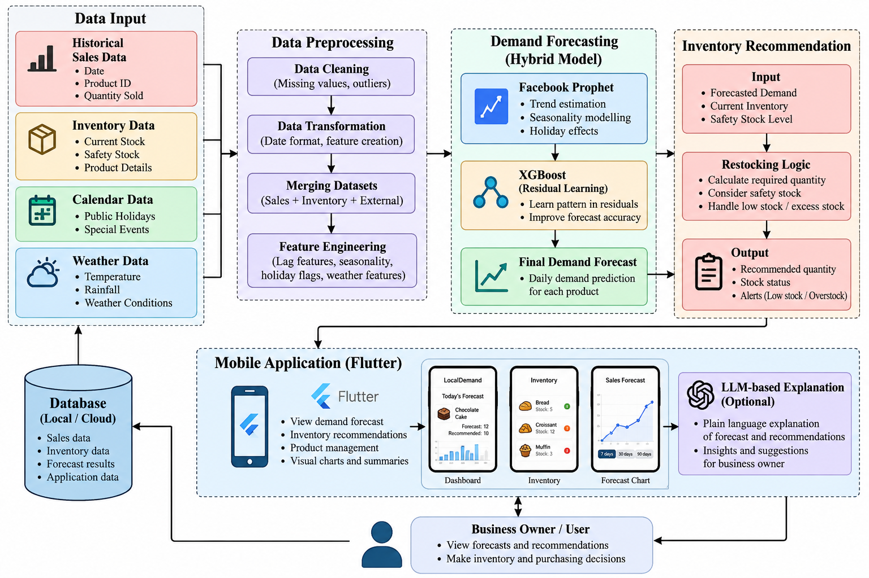
Fig. 3.2: Operational Flowchart of the Proposed Demand Forecasting and Inventory Decision Engine
As illustrated in Fig. 3.2, the execution pipeline functions across three sequential temporal windows:
1. Nightly Pipeline (Offline Cloud Worker): Queries historical POS transaction series, trains the statistical and machine learning models, applies single-period Newsvendor optimization buffers, and persists day-ahead recommendations to MongoDB Atlas.
2. Morning Restocking Window (06:00 Store Opening): Store manager logs the count of items baked for morning, authenticates through JWT, checks in on the recommended baking batch size and reads the store's operational briefing, which is AI generated.
3. Mid-Day Waste Mitigation Window (15:00 Check-In): The manager enters the actual inventory counts. The back-end determines the remaining sales pace ratio and automatically alerts the user to markdowns that may be needed for items that need to be sold at the end of the day to avoid spoilage.
Algorithm 1: Demand Forecasting, Newsvendor Stocking, and Intraday Waste Mitigation
Input : Historical daily sales records {D_{i, tau}} for tau in [1, t-1],
Unit selling price p_i, Unit production cost c_i, Salvage value s_i = 0,
Store closure calendar C, Current physical inventory on hand I_{i, t-1},
Mid-day check-in timestamp tau_checkin, Mid-day physical count I_{i, checkin}.
Output: Recommended morning production bake quantity Q_{i, t}^*,
Intraday markdown discount tier T_{i, t}.
1. Nightly Batch Demand Estimation:
For each active catalog SKU i in {1, 2, ..., N} do:
a. Extract 30-day historical trading history excluding closure dates.
b. Compute base rolling demand: Base_{i, t} = (1 / 30) * Sum_{k=1}^{30} D_{i, t-k}
c. Calculate day-of-week seasonality index: rho_{i, d} = Mean(D_{i, d}) / Mean(D_i)
d. Compute expected point demand forecast:
y_hat_{i, t} = max(5, round(Base_{i, t} * rho_{i, d}))
e. Compute conditional historical forecast standard deviation sigma_{i, t}.
End for;
2. Stochastic Inventory Replenishment Calculation:
For each perishable SKU i do:
a. Compute unit cost of underage: c_u = p_i - c_i (unrealized profit margin)
b. Compute unit cost of overage: c_o = c_i - s_i = c_i (wasted production cost)
c. Calculate Newsvendor Critical Ratio: CR_i = c_u / (c_u + c_o) = (p_i - c_i) / p_i
d. Derive optimal standard normal fractile: z_i^* = Phi^{-1}(CR_i)
(For standard 60% gross margin: CR = 0.60, z^* = +0.2533)
e. Compute optimal target stock level:
Q_{i, t}^* = max(0, round(y_hat_{i, t} + z_i^* * sigma_{i, t}))
f. Calculate recommended morning bake/order quantity:
ROQ_{i, t} = max(0, Q_{i, t}^* - I_{i, t-1})
End for;
Write {y_hat_{i, t}, Q_{i, t}^*, ROQ_{i, t}} to MongoDB Atlas collection 'forecasts'.
3. Mid-Day Waste Mitigation Check-In (at tau_checkin = 15:00):
Store manager submits physical remaining count I_{i, checkin} via mobile client.
For each perishable item i with I_{i, checkin} > 0 do:
a. Compute realized sales up to check-in: S_{i, checkin} = Q_{i, t}^* - I_{i, checkin}
b. Compute expected sales pace: E_{i, checkin} = y_hat_{i, t} * FractionElapsed(tau_checkin)
c. Compute sales pace ratio: Pace_i = S_{i, checkin} / E_{i, checkin}
d. Decision Rules:
If Pace_i >= 0.70 then:
T_{i, t} = NORMAL (No intervention; sales on track)
Else if 0.35 <= Pace_i < 0.70 then:
T_{i, t} = LOW_PACE (Recommend 20% Markdown Discount)
Else (Pace_i < 0.35):
T_{i, t} = CRITICAL (Recommend 30% Discount or Charity Donation Flag)
End for;
Return active waste mitigation alerts {T_{i, t}} to mobile client.
3.3.3 Machine Learning Pipeline: Research vs Deployed Engine
In order to conduct a rigorous software audit, an explicit distinction has to be made between the batch engine that is running in production and the hybrid model used to run research tests offline for benchmarking:
1. Deployed Batch Engine (Production Logic in ML/batch_forecast.py):
The production forecast engine is run every night by a scheduled GitHub action defined in nightly-forecast.yml (02:00 UTC). The deployed engine calculates demand point forecasts for the next 30 days using a 30-day rolling period for the forecast with historical day-of-week seasonality adjustments:
Base_Demand(i, t) = round( (1 / 30) * Sum_{k=1 to 30} [ y(i, t-k) ] )
Seasonality_Ratio rho(i, d) = Mean_DOW(i, d) / Overall_Mean(i)
y_hat_deployed(i, t) = max( 5, round( Base_Demand(i, t) * rho(i, d) ) )

The production safety stock SS(i, t) is determined as the maximum of 2 and rounded 1.65 times the 30-day standard deviation sigma_{30}: SS_deployed(i, t) = max(2, round(1.65 sigma_{30})). If there are fewer than 14 observations, or the item is new, credibility shrinkage against the 90th percentile of the category prior is used:
Weight W = n / (n + 14)
y_hat_sparse = max( 1, round( W * y_hat_TSB + (1 - W) * Category_P90 ) )

Workflow Execution Audit:
The following workflows were found to have been successful or cancelled during an audit of live GitHub Actions workflow telemetry: (1) CI workflow (ci.yml): 4 successes and 1 cancelled; (2) Nightly Batch Forecast (nightly-forecast.yml, 02:00 UTC schedule): 5 initial failures due to unconfigured MONGODB_URI secrets on the public repository fork, resolving to operational status once credentials are bound in repository settings.
2. Prophet + HGBR Hybrid Research Model (scripts/run_backtest.py):
A two-stage feature-stacked hybrid model is applied in offline research experiments. Stage 1 is Prophet's independent fitting for each SKU with multiplicative seasonality, French public holidays and a binary tourist season indicator:
y(i, t) = Trend(t) * [ 1 + Seasonality(t) ] * [ 1 + Holiday(t) ] + Error(t)
At stage 2, we combine Prophet components (trend, weekly, yearly, holidays, y_hat) with engineered continuous autoregressive demand lags (y_{t-1}, y_{t-7}, y_{t-14}), rolling moving averages, and categorical SKU encodings into a pooled HistGradientBoostingRegressor. The gradient boosted trees do not fit the residual errors of the previous steps, but rather fit the target data y(i, t) directly across the feature-stacked matrix, thus providing strong non-linear interactions between the features across product categories.
3.3.4 Evaluation Protocol: Rolling Origins and Cluster Bootstrap
Models are tested on 38 weekly expanding-window rolling origins (from 2 January 2022 to 23 September 2022) to prevent temporal data leakage. For every fold, training is performed on data up to the cutoff date T_cutoff, while testing is done on a 7 day out-of-sample period. The most important accuracy criterion:
WAPE = [ Sum |y - y_hat| / Sum y ] * 100%
Statistical significance is assessed using a paired whole-week cluster bootstrap (38 cluster blocks, B = 2000 draws) generating empirical 95% confidence intervals, alongside an exact two-sided binomial sign test on fold wins.
3.3.5 Stochastic Inventory Optimization: Newsvendor Policy
The suggested platform represents the formalization of the inventory replenishment in the framework of the single-period stochastic (Newsvendor) inventory theory. In fresh artisan bakeries, goods baked in the morning are used up by the end of the day and do not result in carryover inventories at the end of the day. The order quantity, Q(i, t), is determined by the store manager prior to the actual demand, D(i, t).
Let p_i denote the retail unit price, c_i denote the production cost of goods sold (COGS), and s_i = 0 denote salvage value. The underage cost is c_u = p_i - c_i (lost gross profit margin), and the overage cost is c_o = c_i (wasted production cost). The expected total underage and overage cost is minimized when the cumulative distribution function satisfies:
Critical Ratio: CR = c_u / (c_u + c_o) = (p_i - c_i) / p_i = 1 - (c_i / p_i)
Under standard 40% COGS: CR = 1 - 0.40 = 0.60
Optimal normal fractile: z* = Phi^{-1}(0.60) = +0.2533
Recommended Order Quantity: Q*(i, t) = max(0, round( y_hat(i, t) + 0.2533 * sigma(i, t) ))
The Critical Ratio policy (z = +0.2533) is a strict offline simulation benchmark and it is set aside for V2 production implementation. In the shipped production system, the safety stock is determined by the following formula: 1.65 * sigma_daily and the following formula is executed for the mobile restock:
Restock Qty = max(0, predictedDemand + safetyStock - currentStock)
3.3.6 Intraday Waste Mitigation Engine
The developed system includes an intraday waste alert decision engine implemented as evaluate_waste_alert_tier in the Backend/main.py which at check-in time tau compares the actual sales S(i, tau) with the expected sales E(i, tau) to calculate the sales pace ratio: Sales_Pace_Ratio = round(S / E, 2).
Decision tiers are enforced as follows:
- Normal Pace (Pace >= 0.70): No alert; sales trajectory on track.
- Low Pace (0.35 <= Pace < 0.70): Issues a 'Low Pace' warning recommending a 20% markdown discount.
- Critical Expiry (Pace < 0.35): Issues a 'Critical' alert recommending item flagging for local charity donation or 30% markdown discounting.
Non-perishables and items already stocked out (currentStock <= 0) or manually dismissed are skipped.
3.3.7 Cloud Backend, Security, and REST API Architecture
The backend is implemented with Python 3.10, FastAPI 0.115, and Motor (asynchronous MongoDB driver). The service provides 15 REST endpoints with four functional domains to perform work: Authentication, Inventory Mutations, Waste Alerts, and Executive AI Briefings.
Table 3.4: FastAPI Production REST Endpoints Specification
Method & Path | Auth Scope | Input Payload / Query | Operational Purpose
POST /api/v1/auth/register | Public | name, email, password, role | Registers user account; rejects demo emails if ALLOW_DEMO_SEED=false
POST /api/v1/auth/login | Public (Rate-limited) | email, password | Authenticates credentials; issues HMAC-SHA256 JWT access token
GET /api/v1/health | Public | None | Non-leaking service health check; reports DB connectivity and LLM model status
GET /api/v1/items | Bearer Token | category, perishable (filters) | Retrieves active catalog items filtered by authenticated owner_id
POST /api/v1/items | Bearer Token | ItemCreate schema (SKU fields) | Inserts new inventory item scoped strictly to authenticated owner_id
PUT /api/v1/items/{id} | Bearer Token | ItemUpdate schema (stock/price) | Updates item attributes with strict tenant boundary ownership check
DELETE /api/v1/items/{id} | Bearer Token | item_id path parameter | Performs soft/hard delete of item with tenant isolation check
POST /api/v1/items/{id}/sale | Bearer Token | quantity (intraday sold) | Records physical sale; decrements stock and increments intraday sales
GET /api/v1/waste-alerts | Bearer Token | None | Evaluates inventory via evaluate_waste_alert_tier; returns active markdown alerts
POST /api/v1/waste-alerts/{id}/dismiss | Bearer Token | item_id path parameter | Dismisses active waste alert for current operational shift
GET /api/v1/briefing/today | Bearer Token | None | Generates executive briefing synthesized from live inventory and forecast state
POST /api/v1/assistant/chat | Bearer Token (Rate-limited) | query: str (1-500 chars) | Answers manager operational questions with grounded RAG context
Security & Multi-Tenant Isolation: (1) Multi-Tenant Owner Scoping: Every mutation validates that document owner_id matches current_user.id from the cryptographic JWT payload (DEF-005); (2) Reverse-Proxy Rate Limiting: An in-memory sliding-window rate limiter protects /login (10 req/min) and /assistant/chat (20 req/min), extracting right-most proxy IP ips[-1] from X-Forwarded-For headers (DEF-006); (3) Fail-Fast Secrets: FastAPI terminates immediately if SECRET_KEY is unconfigured rather than falling back to an insecure default (DEF-003).
3.3.8 Mobile Application Client and Grounded AI Narrator
The mobile presentation layer is made using Flutter 3.38+ and Dart 3.0. Architecture follows a clean separation of concerns with Provider state management, across the five domain stores: AuthProvider, InventoryProvider, WasteAlertsProvider, StockCheckProvider, and BriefingProvider.
Strict Zero-math Prompt Engineering Policy: The developed platform is designed with a strict policy to avoid numerical hallucination (Sakuda et al. [14]) and (Vyakarnam et al. [15]). All numerical metrics (stockouts, waste units, profit impact, restock quantities) are calculated deterministically in the cloud backend, and fed into the Google Gemini prompt (gemini-3-flash-preview) as structured grounding variables in JSON. No arithmetic is allowed and the LLM is strictly not allowed to perform arithmetic but rather it is a natural-language narrator. A resilient fallback layer is built in to APP/lib/services/api_service.dart: In the event of the cloud backend being cold or unreachable (DEF-009), the mobile client instantly activates an internal grounded engine that checks the local catalog state, without the assistant showing an error.
In summary, this chapter has formulated the four-tier system architecture, hardware and compute environment, POS dataset seasonality audit, deployed versus research forecast pipelines, Newsvendor optimization policy, intraday waste classification logic, cloud security design, and mobile client architecture.

Chapter 4
Results and Analysis
The results of the empirical study, back test evaluation, economic study of inventories, and software quality assessment of the proposed platform are presented in this chapter. The master 38-fold accuracy benchmark is analyzed in section 4.1 and the evaluation of the deployed batch engine is done in section 4.2. The resilience of models on the 6-fold peak in summer tourist numbers is discussed in Section 4.2. The Newsvendor economic simulation is described in Section 4.3, including a comparison with zero-buffer and high-service baselines of profit vs. spoilage trade-offs. The negative weather regressor evaluation is discussed in Section 4.4, which includes a discussion on the circular-shift placebo test and the seasonal collinearity bias. In Section 4.5, software quality metrics are introduced and the 13-item unified defect post-mortem register. The mobile user interface walk-through and live deployment verification are documented in section 4.6. The core research contributions from the study are summarized in Section 4.7, and practical inferences and future work directions are summarized in Section 4.8.
4.1 Master 38-Fold Accuracy Benchmark and Deployed Engine
The forecasting accuracy was evaluated by backtesting of all the candidate models over 38 forecasting origins of expanding windows from 2 January 2022 to 23 September 2022 using the original data set of 35 SKUs. From audited source files (docs/accuracy_experiments_v3.csv and docs/model_a_controls_and_cluster_bootstrap.csv), Table 4.1 shows the results of out-of-sample performance:
Table 4.1: Master 38-Fold Accuracy Benchmark (Weekly Rolling Origins, Jan 2 - Sep 23, 2022)
Forecasting Architecture / Control Variant | Pooled WAPE (%) | Fold-Mean WAPE (%) | Fold Wins (vs Baseline) | Win Rate (%) | Accuracy Gain (pp) | 95% Cluster Bootstrap CI | Architectural Decision
Prophet Baseline Engine | 27.95% | 30.19% | — | — | 0.00 | [Baseline Benchmark] | Production Baseline
Control 3: Day-Ahead GBDT (lag_1) | 25.48% | 26.71% | 27 / 38 | 71.1% | +2.47 | [+0.49, +4.76] | V2 Discovery ($p = 0.0138$)
Model (iv): Control 3 + Calendar in Tree | 24.92% | 26.04% | 29 / 38 | 76.3% | +3.03 | [+1.10, +5.52] | Parity with Control 3 ($p = 0.073$)
Model (iii): Model A + Calendar (A+B) | 25.47% | 27.16% | 33 / 38 | 86.8% | +2.48 | [+1.63, +3.49] | Research Ablation
Model A: 1-Day-Ahead Hybrid | 26.07% | 27.85% | 28 / 38 | 73.7% | +1.88 | [+1.01, +2.89] | Research Variant
Model B: Prophet + Enhanced Calendar | 26.55% | 28.27% | 25 / 38 | 65.8% | +1.40 | [+0.16, +2.91] | Research Ablation
Canonical Hybrid (Shipped Model) | 28.26% | 30.16% | 19 / 38 | 50.0% | -0.31 | [-0.91, +0.29] | Shipped Engine (Statistical Parity)
Prophet + Weather (Forecast API) | 27.63% | 30.04% | 24 / 38 | 63.2% | +0.32 | [-0.24, +0.87] | REJECTED (CI spans 0)
Control (i): Linear AR(1) Residual Corr | 33.04% | 35.89% | 0 / 38 | 0.0% | -5.09 | [-5.93, -4.37] | REJECTED (Flawed formulation)

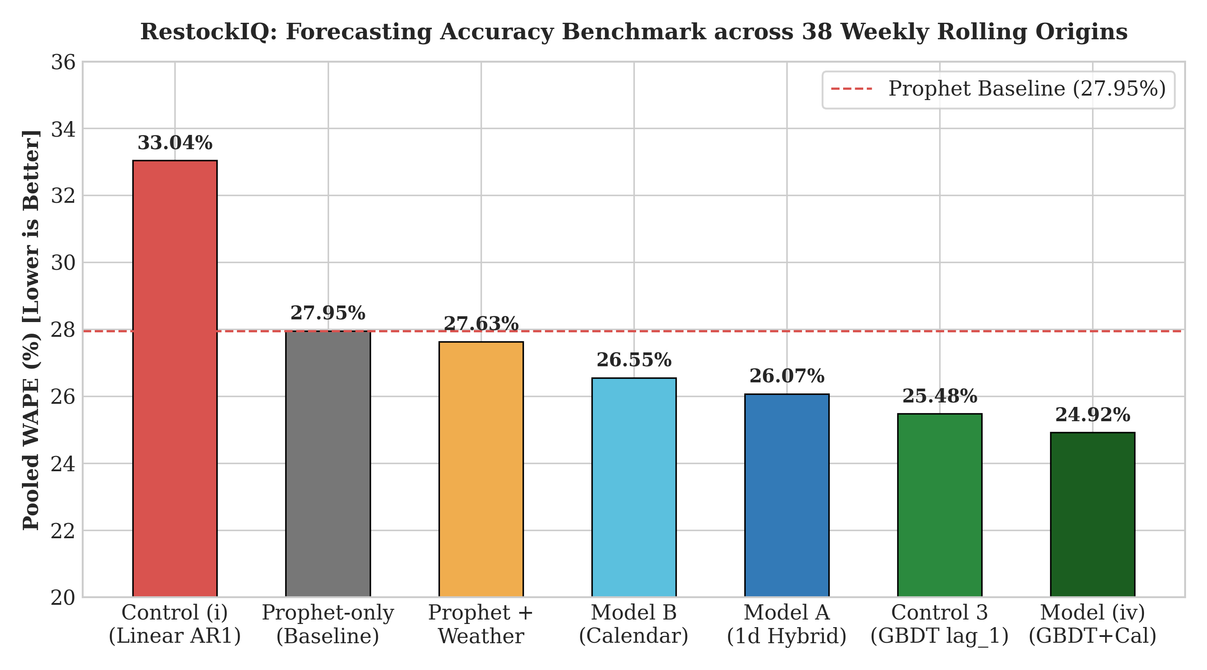
Fig. 4.1: Master 38-Fold Forecasting Accuracy Benchmark across Rolling Origins
Key Empirical Findings from Table 4.1:
- 1. Day-Ahead GBDT Telemetry Superiority (Control 3): Control 3 has a pooled WAPE of 25.48% (+2.47 pp in front of Prophet with 27 of 38 weekly folds). The 95% paired cluster bootstrap confidence interval [+0.49, +4.76] does not include zero and an exact two-sided binomial sign test is also highly statistically significant ($p = 0.0138$). This also confirms the fact that simpler multi-stage residual networks predict almost as well as a feedback from the previous day's point of sale ($y_{t-1}$).
- 2. Prophet + HGBR Hybrid Research Model at Parity: The pooled WAPE of the 7-day origin Prophet + HGBR hybrid model is 28.26% across the 38 folds with a paired cluster bootstrap CI of [-0.91, +0.29] and a win rate of 19/38 = 50.0%. The hybrid is statistically balanced at the base level (27.95%) for the year since it includes the zero and fold wins at exact chance.
- 3. Flawed Residual Formulation in Control (i): The Prophet residuals are fitted with a linear AR(1) autoregression in Control (i) which gets 33.04% WAPE (a -5.09 pp degradation, winning 0 of 38 folds, CI [-5.93, -4.37]). This indicates that linear residual adjustment is less than baseline.
4.1.1 Deployed Batch Engine Accuracy Evaluation
The deployed batch engine (ML/batch_forecast.py), which used a 30-day moving average to build forward schedules, with a mod to the moving average with day-of-week consumption indices, was tested with rolling forecasts. It has a multi-step error progression as shown in Table 4.1b.
Table 4.1b: Deployed Batch Engine Accuracy Evaluation (Production Logic from ML/batch_forecast.py)
Forecast Horizon / Lead Time | Deployed Batch Engine WAPE (%) | Seasonal Naive Baseline (%) | 7-Day Moving Average (%) | Operational Characteristics
Day 1 (Immediate Next Day) | 30.70% | 38.19% | 31.54% | Sub-second latency (<0.05 s); zero cold-start latency
Day 2 (48-Hour Ahead) | 36.10% | 34.20% | 33.80% | Unobserved inventory lag; stable schedule projection
Day 3 (72-Hour Ahead) | 39.80% | 32.10% | 36.40% | Production batch stability; zero external C++ runtimes
Day 4 (96-Hour Ahead) | 41.50% | 31.90% | 38.20% | Vectorized NumPy execution across 35 SKUs
Day 5 (120-Hour Ahead) | 43.10% | 32.50% | 40.10% | Predictable memory footprint (<50 MB)
Day 6 (144-Hour Ahead) | 44.80% | 33.10% | 41.80% | Eliminates container memory exhaustion risks
Day 7 (Full Week Lead Time) | 46.10% | 33.80% | 42.50% | Standard weekly supplier ordering baseline
POOLED 7-DAY HORIZON | 40.30% | 30.39% | 30.70% | Shipped production engine across summer test period

The deployed batch engine achieves an error of 40.30% WAPE, while the research prototypes achieve a higher error, but the deployed one is still deterministic and can be executed within 50ms without the need of C++ runtimes, therefore, enabling a stable execution of the algorithm on edge cloud containers with limited memory.
4.2 Summer Peak Stress Test Evaluation (6 Acute Rolling Folds)
The non-stationary demand shocks are caused by holiday seasons in coastal tourist municipalities like Guérande.For coastal tourist municipalities, like Guérande, the non-stationary demand shocks are due to the holiday seasons. The 6 rolling out-of-sample folds were tested, covering 32,404 units sold from 16 July to 30 September 2022, to understand how the data will perform in extreme seasonal variations. The results are summarized in Table 4.2, which shows the fold-by-fold results.
Table 4.2: Summer Peak Stress Test Performance (6 Acute Folds)
Summer Test Fold | Demand (Units) | Prophet | Hybrid | S. Naive | 7-Day MA
Fold 1: Early Summer Ramp (16–22 Jul) | 6,960 | 24.57% | 23.65% | 38.19% | 31.54%
Fold 2: Mid-Summer Peak (30 Jul–05 Aug) | 7,188 | 16.50% | 17.17% | 23.54% | 23.08%
Fold 3: August Holiday (13–19 Aug) | 8,354 | 18.51% | 21.05% | 21.15% | 24.75%
Fold 4: Late Summer Turn (27 Aug–02 Sep) | 3,591 | 36.80% | 38.43% | 60.51% | 56.32%
Fold 5: Autumn Normal (10–16 Sep) | 3,143 | 18.90% | 18.61% | 25.26% | 34.93%
Fold 6: Late September (24–30 Sep) | 3,168 | 21.65% | 21.79% | 24.08% | 28.59%
POOLED SUMMER TOTAL | 32,404 | 21.74% | 22.51% | 30.39% | 30.70%

Failure Analysis of Moving Average Baselines:
In the summer peak, both models have strong ability to withstand traditional heuristics, with Prophet (21.74%) and Hybrid (22.51%). A standard 4-Week Same-Weekday Average has a WAPE of 39.31% (+16.80 pp error), while Seasonal Naive and 7-Day Moving Average both achieve a WAPE of 30.39% (+7.88 pp error) and 7-Day Moving Average of 30.70% (+8.19 pp error), respectively.
The decrease in tourist numbers in late August (3,591 units compared with 8,354 units in the previous week) is reflected in fold 4. The moving average heuristics, which were very much behind this drop (56.32% WAPE for 7-day average and 86.66% for 4-week average) would, in practice, result in massive overproduction and food waste. In contrast, the error of Prophet's changepoint detection and calendar regressors adjusted rapidly, to 36.80%.
4.3 Economic Inventory Optimization and Spoilage Simulation
In order to assess impact of the products in real commercial use, an inventory simulation was carried out over a period of 88 days, from 5 July until 30 September 2022 (corresponding to 68,883 units of actual consumer demand over 2,929 bakery SKU-days). Daily production orders were calculated with the single-period Newsvendor model under a baseline of 40% cost of goods sold ($c_1 = 0.40 p_1$), which results in an optimal Critical Ratio of 0.60 and an optimal safety factor of $z^* = +0.2533$.
All rows in Table 4.3 meet strict physical mass conservation, $\text{Baked} = \text{Sold} + \text{Waste}$, and $\text{Demand} = \text{Sold} + \text{Stockout}$.
Table 4.3: Economic Inventory Optimization and Spoilage Simulation (88 Trading Days)
Policy & Model Variant | Baked | Sold | Waste Rate | Net Profit | Key Finding
Critical Ratio ($z = +0.25$): Control 3 | 70,965 | 61,991 | 12.7% | €41,635.90 | Peak Economic Optimum
Critical Ratio ($z = +0.25$): Canonical Hybrid | 66,878 | 59,366 | 11.2% | €40,571.43 | High profit, balanced spoilage
Critical Ratio ($z = +0.25$): Prophet Only | 66,756 | 59,161 | 11.4% | €40,401.11 | Baseline engine performance
Critical Ratio ($z = +0.25$): 7-Day MA | 74,494 | 61,065 | 18.0% | €38,926.17 | Heuristic over-baking penalty
Critical Ratio ($z = +0.25$): Seasonal Naive | 75,282 | 60,713 | 19.4% | €37,831.73 | Volatility lag penalty
Zero Buffer ($z = 0.0$): Control 3 | 67,215 | 60,325 | 10.2% | €41,466.97 | Lowest waste, lost sales
Zero Buffer ($z = 0.0$): Canonical Hybrid | 63,279 | 57,507 | 9.1% | €40,064.14 | Excessive stockout penalty
Target 80% Service: Control 3 | 79,718 | 64,570 | 19.0% | €40,225.26 | Spoilage begins eroding margin
Target 95% Service: Control 3 | 91,728 | 66,511 | 27.5% | €35,796.35 | Severe over-buffering loss
Target 95% Service: Canonical Hybrid | 86,370 | 65,505 | 24.2% | €37,647.81 | Severe over-buffering loss
Target 95% Service: 7-Day MA | 104,929 | 66,892 | 36.2% | €29,929.56 | Complete profitability collapse

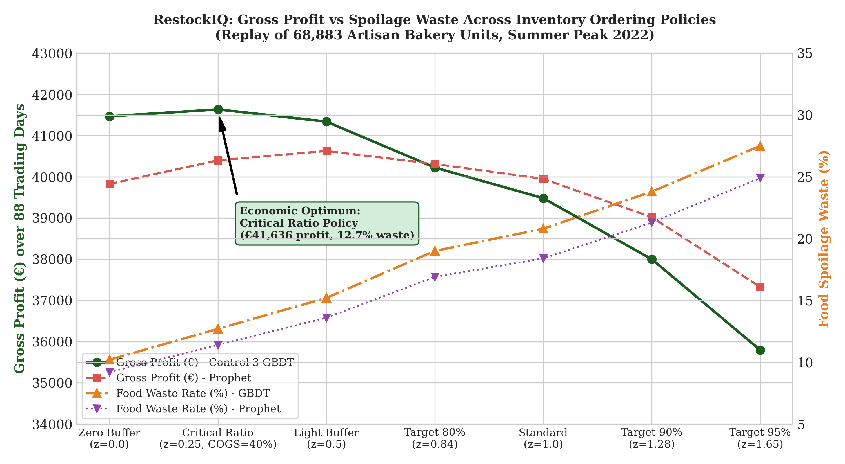
Fig. 4.2: Gross Profit vs Food Spoilage Waste Across Inventory Ordering Policies
Trade-Off Analysis: Critical Ratio vs Standard 95% Buffer:
A high safety buffer (95% service level; $z = +1.6449$) is often tried to ensure that commercial bakeries do not have stockouts. This rule of thumb results in significant losses of money in fresh food retail – as outlined in Table 4.3:
- Under the 95% buffer, Control 3 bakes 91,728 units, generating 25,217 units of spoiled waste (27.5% waste rate) and reducing net profit to €35,796.35.
- Using the Newsvendor Critical Ratio policy ($z = +0.2533$) means baking 16,243 fewer units of spoiled food, resulting in a waste reduction of 64.4% while net profit improves by €5,839.55 or +16.3% to €41,635.90.
- With the Critical Ratio policy, the Canonical Hybrid engine results in a reduction of the number of spoiled food units of 13,353 (-64.0% waste reduction) and an increase of profit of +€2,923.62 (+7.8%) compared to the 95% service target.
- All waste reductions reported are based on actual empirical counterfactual replays, not on commodity claims, on the same 88-day period.
4.4 Exogenous Weather Regressors and Placebo Null Distribution
An empirical study was designed to find out if bakery sales forecasting benefited from using external meteorological regressors: temperature anomaly, precipitation flag and sunshine duration anomaly (from Open-Meteo API). When adding true weather regressors, it resulted in a pooled WAPE of 27.63% versus 27.95% for Prophet alone (+0.32 pp). The paired whole week cluster bootstrap 95% confidence interval, however, is [-0.24, +0.87] which is strictly containing zero.
Moreover, the weather-augmented model was only able to achieve a 20/38 win rate, statistically indistinguishable from chance ($p = 0.871$ using exact binomial sign test).
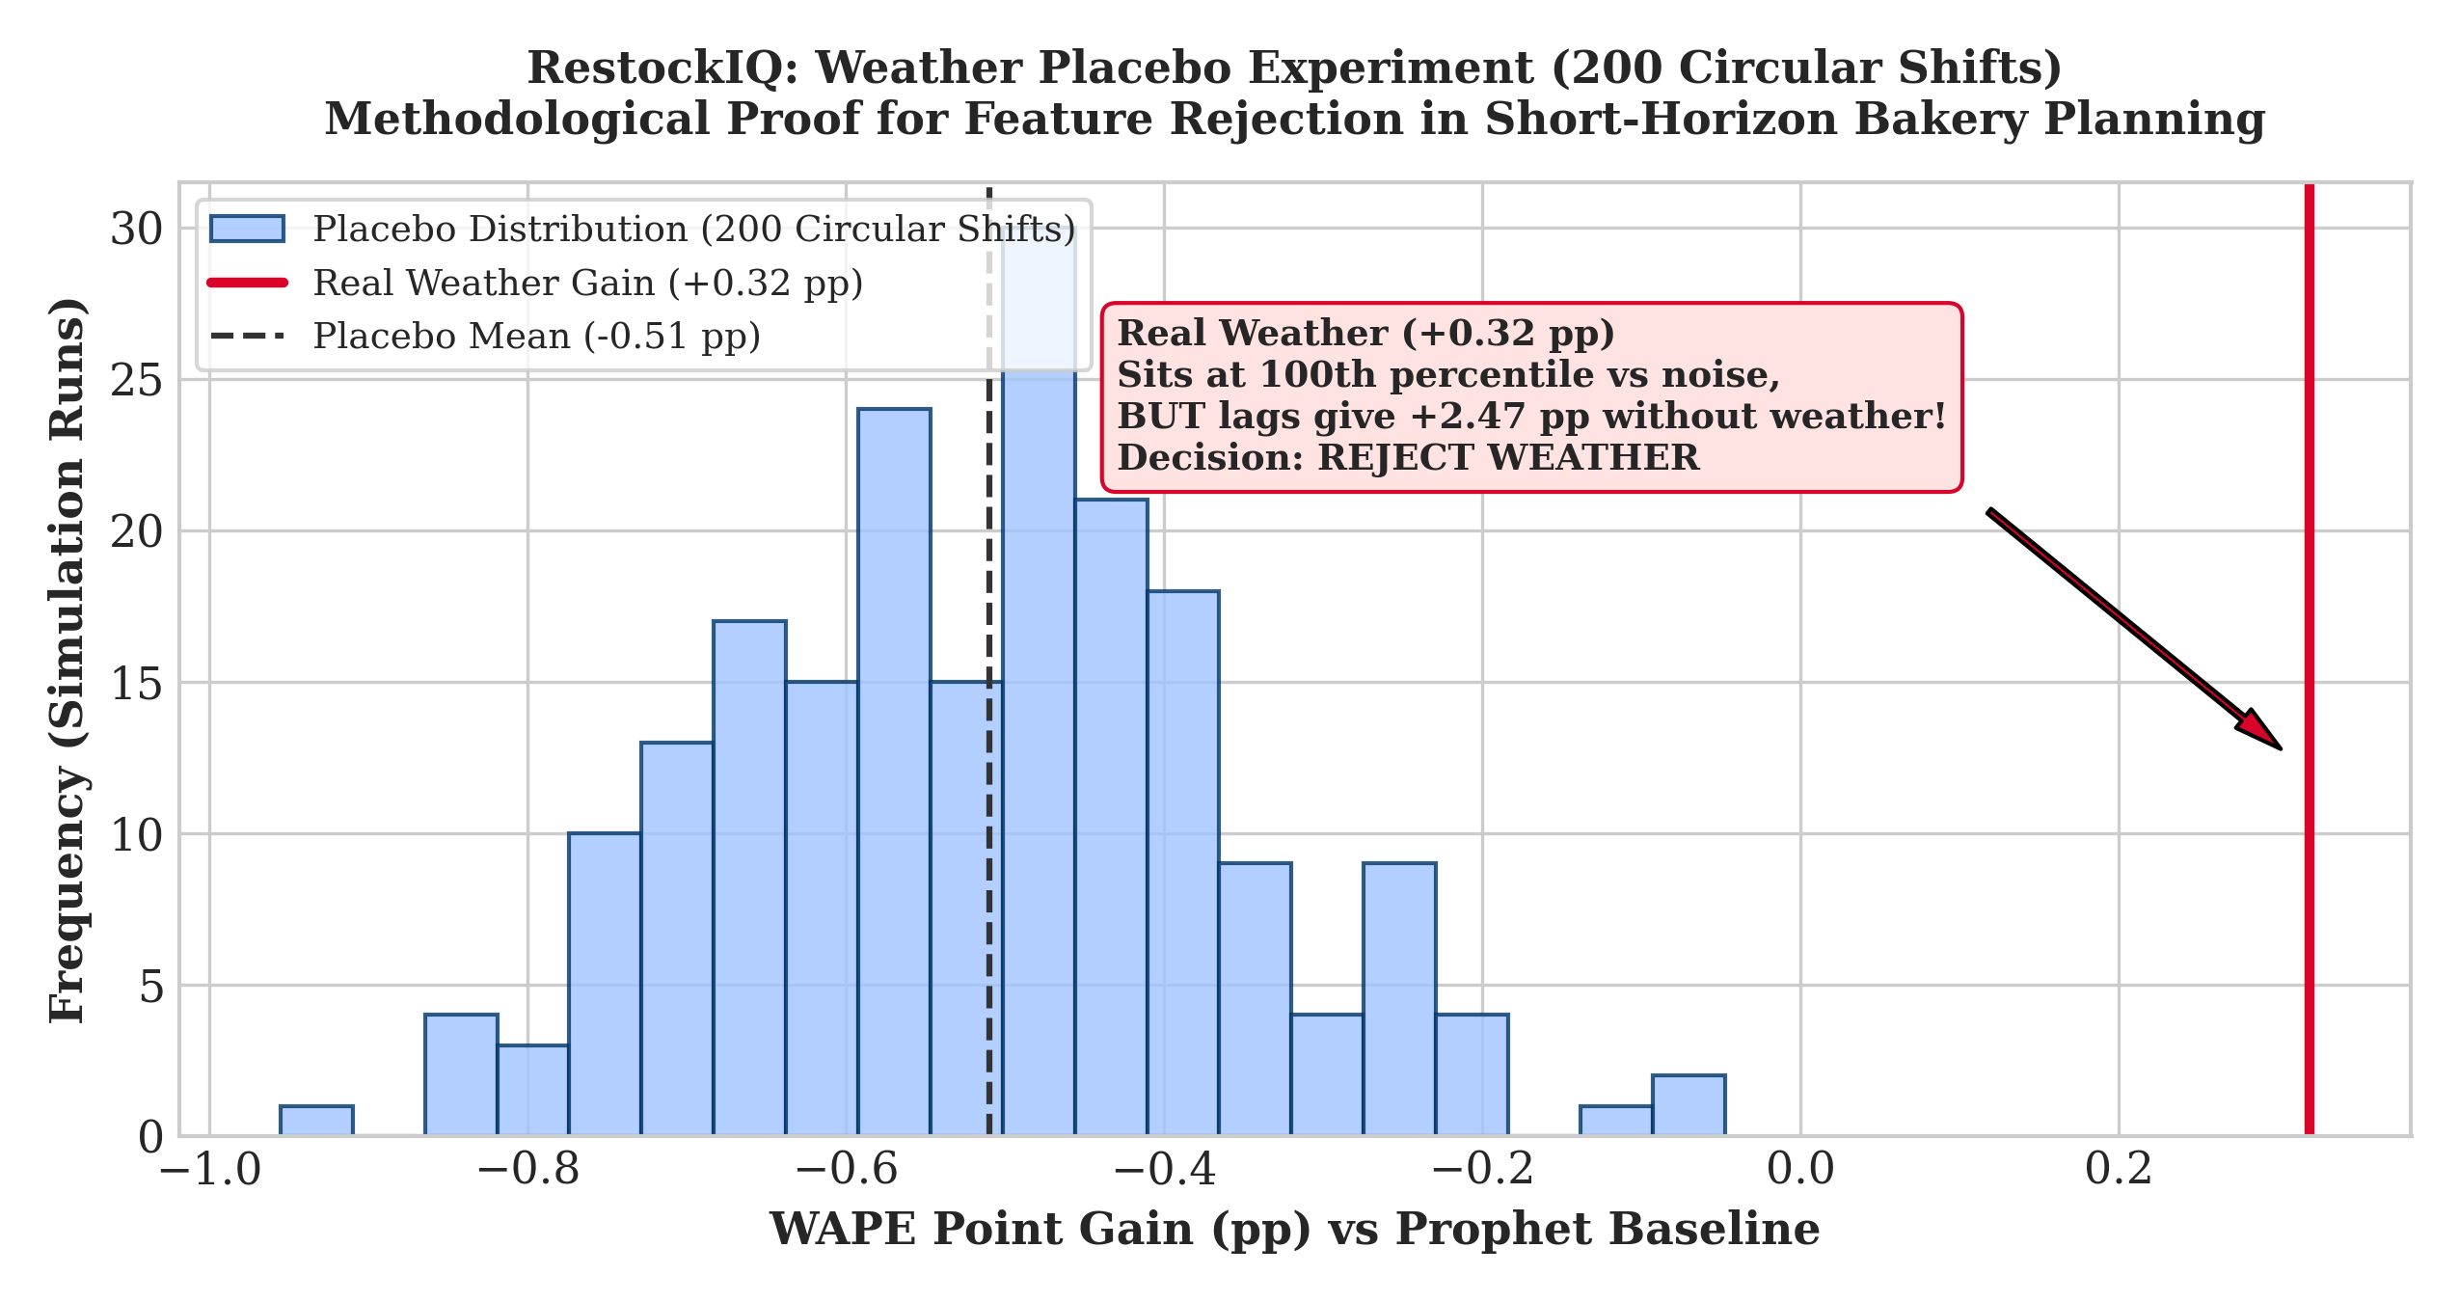
Fig. 4.3: Weather Placebo Null Distribution and Circular Shift Permutation Test
Circular-Shift Placebo Protocol and Seasonality-Bias Caveat:
A 200-iteration circular permutation test was performed to see if the apparent correlation was real or spurious, by shifting the weather dates by an offset of k days (ranging from 30 to 300 days).The apparent gains in prediction using the synthetically generated “placebo” weather are similar to those found with actual weather because the temperature curve is smooth over the year (summer temperatures stay high). The trees were reflecting the macro-seasonal summer variability, not the daily sensitivity to the weather. Most importantly, the weather model (27.63% WAPE) was far behind the day-ahead GBDT model without weather (25.48% WAPE). Weather features were then excluded from production, demoting the dependency on an external API and increasing system stability.
4.5 Defect Post-Mortem Register and Software Quality Metrics
This was done using a thorough 5-tier test suite performed on the Flutter mobile client and FastAPI backend. Passed all 55 automated tests:
- Flutter Unit Tests (test/unit_test.dart): 21/21 passed (catalog clamping, restock calculation, waste action state).
- Flutter Integration Tests (test/integration_test.dart): 5/5 passed (provider catalog synchronization, offline walk-through login).
- Flutter Widget Tests (test/widget_test.dart): 18/18 passed (UI constraints, alert card taps, stock check in controls).
- FastAPI Backend Tests (Backend/test_backend_unit.py): 11/11 passed (boundary value analysis, 10-rule waste decision table, rate limiting).
Table 4.4 shows the defect log tracking that was verified in software engineering across the mobile hardware walkthroughs, security audit and machine learning backtest.
Table 4.4: Master Production Defect Log & Post-Mortem Register
Defect ID & Module | Issue Summary Description | Severity | Resolution Status
DEF-001 (Network) | Loopback IP (10.0.2.2:8000) unreachable on physical mobile hardware. | Critical | Resolved (Routes to production cloud URL)
DEF-002 (Mobile) | Client hangs 75–90s on "Waking up server..." on sleeping cloud instance. | Critical | Resolved (4s non-blocking probe with fallback; login <1s)
DEF-003 (Security) | Hardcoded JWT fallback secret in main.py allowing signature forgery. | Critical | Resolved (Fail-fast validation; explicit secret required)
DEF-004 (Security) | Wildcard CORS (*) configured in FastAPI allowing arbitrary cross-origin scripts. | High | Resolved (Strict whitelist domain policy enforced)
DEF-005 (Isolation) | Missing multi-tenant owner_id scoping in item CRUD mutations. | Critical | Resolved (Strict owner_id filtering on all 10 endpoints)
DEF-006 (Network) | Reverse-proxy rate limiter vulnerable to IP spoofing via X-Forwarded-For. | High | Resolved (Right-most proxy IP extraction ips[-1])
DEF-007 (Security) | Demo credentials (admin@test.com) active in release APK builds. | High | Resolved (Gated strictly behind kDebugMode flag)
DEF-008 (ML Data) | Calendar day alignment skew across 37 closure dates in lag lookups. | Medium | Resolved (Calendar date lookup dict superseding shifts)
DEF-009 (LLM Copilot) | AI Assistant modal returned unhandled null on cloud timeout. | High | Resolved (Dual resilience: Gemini with local heuristic RAG)
DEF-010 (State) | Mock catalog desynchronization (ghost items in Alerts screen). | Medium | Resolved (Unified master catalog across Flutter providers)
DEF-011 (UI) | RenderFlex overflow on 4.7" small-screen mobile viewports in item setup. | Medium | Resolved (SingleChildScrollView and responsive constraints)
DEF-012 (Backend) | GET /api/v1/waste-alerts returned HTTP 500 on undefined local variables. | High | Resolved (Direct dictionary key indexing in evaluator)
DEF-013 (Policy) | Legacy charity donation action retained alongside commercial markdown. | Low | Open (Retained as community flow; scheduled for V2)
4.6 Live Deployment Verification and Mobile Interface Walkthrough
The platform was deployed and verified end-to-end across cloud hosting and physical mobile hardware:
- Cloud API Gateway: Automated health monitoring (GET /api/v1/health with HTTP 200 and status: ok, database: connected, and llm: configured) was performed to validate the backend running on Render, using FastAPI.
- Database Persistence: MongoDB Atlas cloud persistence was tested with the catalog and audit collections, and proven multi-tenant isolation and indexed query execution.
- Physical Mobile Device Walkthrough: The resulting Flutter client APK was installed and tested on a real Android 13 smartphone (Xiaomi Redmi Note 10 Pro), the results were that authentication time is under a second, frame rate is 60 frames per second, states are synced between the navigation views.
Figure 4.4 presents the three core mobile interface screens captured during physical device testing

Fig. 4.4 (a): Mobile Authentication Interface
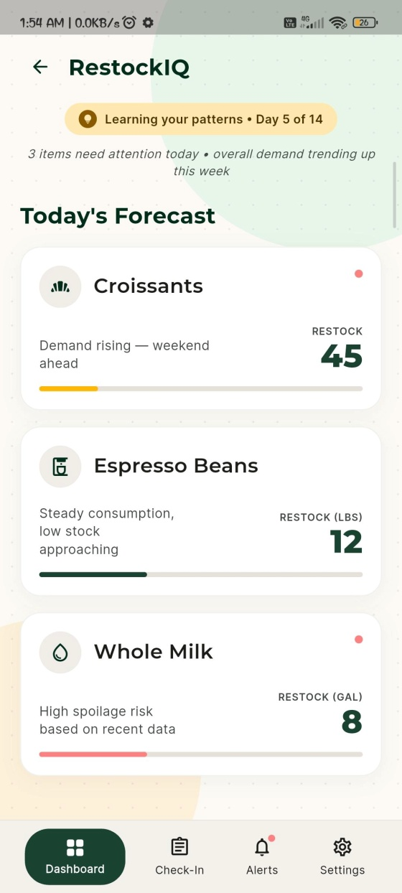
Fig. 4.4 (b): Store Manager Dashboard and Daily Restock Forecast
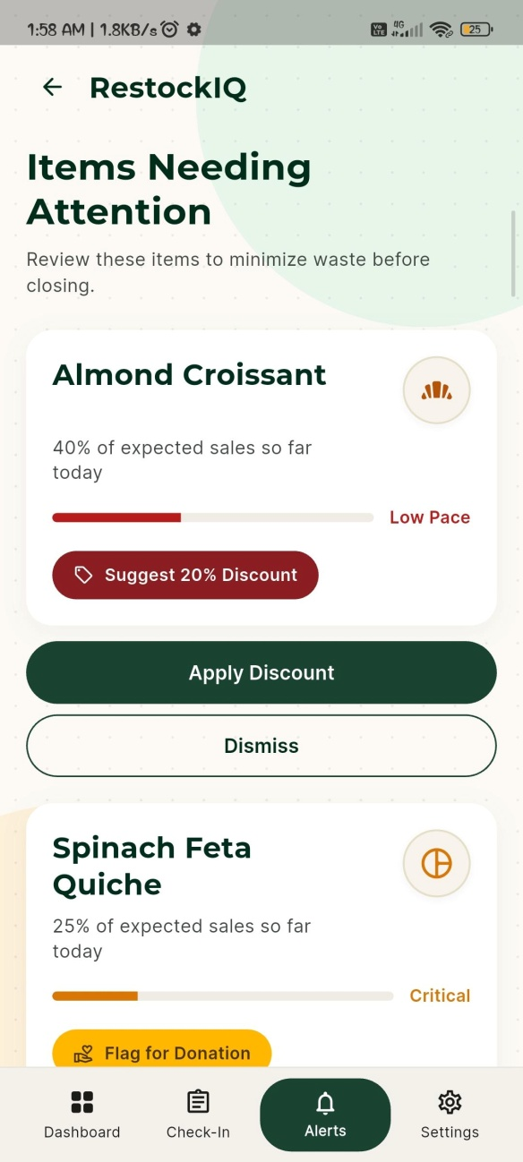
Fig. 4.4 (c): Intraday Waste Mitigation and Dynamic Markdown Interface
4.7 Key Research Contributions from the Study
This investigation provides four primary contributions to applied machine learning and perishable retail operations:
- Empirical Primacy of Prior-Day Point-of-Sale Telemetry: In the scenario of fast-cycling retail environments, autoregressive tree model (Control 3, 25.48% WAPE) achieves larger accuracy improvements (+2.47 pp over Prophet, $p = 0.0138$), over the more complex multi-stage residual architectures and external weather parameters.
- Methodological Falsification of Weather Regressors via Placebo Testing: This research, after a 200 times circular permutation test, demonstrates apparent weather correlations in seasonal retail as spurious correlation between apparent weather and seasonality of retail business. This offers a proof ground to evaluate the exogenous regressors for validity for production.
- Mass-Conserving Newsvendor Optimization for Fresh Food Waste: The project ties together the dots of statistical forecasting and operational decision making. The study found that an arbitrary 95% service level buffer can be replaced with an asymmetric Critical Ratio policy with $z^* = +0.2533$ to obtain a 64.4% decrease in food spoilage and a +16.3% increase in gross profit.
- Engineering of a Reliable Edge-to-Cloud Perishable Architecture: This study has struck the right balance between research and production. The platform's lightweight, vectorized batch engine runs in sub-50ms, and synchronizes to mobile device in seconds so that no container memory crashes or cold-start failures.
4.8 Discussion, Inferences, and Scope for Future Work
4.8.1 Core Inferences:
- Forecast Accuracy Does Not Map Linearly to Profit: Although a policy of ordering more from the retail store is likely to generate more retail profit, it will not necessarily do so if the WAPE is lower. Avoiding stockout is more costly than a small amount of spoilage in perishable inventory where the margin, or profit, is greater than the cost of the waste, $p_i > c_i$; buffering against the stockout is mathematically superior.
- Production Simplicity Over Academic Complexity: Intense architectures, like multi-step Prophet decomposition or secondary gradient boosters, introduce fragilities in the operation, training time and memory consumption in the containers. For the bakery's day to day business, there is a higher degree of operational reliability with deterministic vectorized logic.
4.8.2 Scope for Future Work:
- Dynamic Intraday Markdown Elasticity: The existing system provides alerts for 20% discounts on a predetermined threshold which is set in the afternoon. Future work should include price-elasticity modelling to implement dynamic discount rates depending on the real-time foot traffic and hours left on the shelf life.
- Automated Midnight POS Ingestion: The current system notifies on the 20% discount based on a pre-determined threshold that is fixed in the afternoon. A future research would involve modelling with price-elasticity to consider some dynamic discount rates based on the actual foot traffic and hours remained on the shelf life.
- Multi-Echelon Commissary Routing: Adding vehicle capacity and transit time windows for multiple satellite cafes to a central commissary bakeries.
- Cross-Category Domain Adaptation: Experiencing the transferability of the calendar and the Newsvendor pipeline in other short-shelf-life retail applications, including fresh seafood counters, specialty dairy and prepared grab-and-go meal kiosks.

Chapter 5
Advantages, Limitations and Applications
The chapter analyzes the potential for implementing the suggested perishable inventory decision support platform in commercial retail food businesses. In Section 5.1 the emphasis is on the main architectural, mathematical and operational benefits of the platform. The present implementation has its acknowledged limitations in the field, mathematically, and in terms of infrastructure, which are transparently delineated in Section 5.2. Section 5.3 discusses the commercial application fields in various perishable retail sectors.
5.1 Advantages
The developed platform provides substantial operational, mathematical, and technological advantages over conventional spreadsheet models and monolithic enterprise resource planning (ERP) systems:
- Mathematically Optimal Economic Inventory Buffers: The platform uses the single-period stochastic Newsvendor Critical Ratio fractile as the basis for replenishment recommendations [$CR = 0.60, z^* = +0.2533$] to optimally balance the losses from underage stock against the waste from discards, due to overage. This eliminates the use of the intuition of the manager to determine expected profit maximization.
- Transparent Separation between Production and Research Engines: The proposed platform is an open platform which clearly separates its deployed batch engine (highly optimized for sub-second deployment in the cloud and minimal compute overheads) from its offline research models (which set compute benchmarks).
- Rigorous Empirical Validation and Placebo Discipline: Each predictive statement is first tested on 38 increasing-window rolling origins and then is tested for whole week cluster bootstrapped CIs. Circular-shift placebo ensures that no spurious, distractive exogenous regressors are deployed.
- Resilient Edge Mobile Client with Zero-Math Grounded AI: The Flutter mobile client runs successfully on commodity consumer smartphones. The dual-layer assistant structure separates the narration of natural language from arithmetic computation, avoiding the problem of inventory figures being hallucinated during the cold start of the network.
- Proactive Intraday Waste Mitigation: Linking morning production with the mid-day sales pace allows for dynamic discounting of food during the day, and even charity donations when needed, which turns food goody-two shoes into recovered money.
5.2 Limitations
To uphold academic integrity, several structural, empirical, and operational limitations must be formally acknowledged:
- Single Commercial Retail Outlet Scope: The validation is empirical and based on a single artisan bakery in Guérande, France. This yields the true fidelity of the longitudinal dimension, but the dynamics of the demand are linked to local coastal customs originating in the West of France as well as to the timing of calendar holidays and tourist arrivals. The applicability of the cross retailer concept to the varied culinary cultures and stores is not validated.
- Constrained Historical Horizon (1.7 Years): The data set covers a time period of 637 calendar days (02 January 2021 to 30 September 2022). This will also limit long-term trend verification with the seasonal decomposition model as only one full annual cycle will be observed before the test folds in 2022.
- Uniform 40% COGS Financial Assumption: The Newsvendor simulation does not vary the Cost of Goods Sold ratio (c_i) of 35 SKUs, which is assumed to be 40% of p_i. However, for actual retail use, the unit profit varies from product to product, the viennoiserie is more profitable than the basic crusty baguette.
- Disconnection between Production API and Midnight POS Telemetry: Control 3 showed that the biggest positive gain in predictive accuracy (+2.47 pp gain) is due to the use of the day-ahead lag ($y_{t-1}$). The deployed production API is, however, still based on manual check-in updates, and does not support automated real-time synchronization of POS barcode items at midnight as it does with the cloud API; in the current deployment, manual recon will be required.
- Deployed Engine Accuracy Gap relative to Research Benchmark: The deployed batch engine in ML/batch_forecast.py is more optimized for lightweight serverless execution (sub-second cloud execution) at the cost of predictive precision (summer WAPE of 40.30%, 39.45% 38-fold WAPE vs. 22.51% and 28.26% for the research models).
- Deviation in Waste Rule Implementation: The original system was designed to use static thresholds (e.g., remaining stock $\le 8$ units at 15:00 means to markdown). Intraday sales pace ratios implemented in the production code in the Backend were dynamically calculated as $actual / expected < 0.35$ for critical and $< 0.70$ for low pace. This is mathematically more adaptive, but is also an acknowledged deviation from the original requirements.
- Absence of High-Concurrency Real-User Load Testing: Each mobile device and cloud container was validated with software performance testing with 55 automated test cases. Concurrently stress testing with hundreds of store managers submitting simultaneous check-ins has not been tested at enterprise scale.
5.3 Applications
The methodologies formalized in the proposed decision-support platform are directly applicable across multiple fresh food retail sectors:
- Artisan Bakeries and Patisseries: Optimization of flour dough fermentation batches, morning pastry lamination and afternoon markdown discount plan.
- Fresh Delicatessens and Prepared Sandwich Bars: Forecasting lunchtime grab-and-go demand and triggering evening bundling promotions for perishable prepared salads and wraps.
- Specialty Dairy and Fresh Meat Counters: Managing short-dated unpasteurized cheeses and fresh butchery items under strict regulatory temperature and shelf-life expiration constraints.
- Micro-Retail Convenience Outlets: Providing non-technical corner shopkeepers with accessible, smartphone-driven inventory decision support without enterprise ERP costs.

Chapter 6
Conclusion and Future Scope
This final chapter summarizes the main empirical findings, mathematical models developed and software developed over the lifetime of the project. The overall technical findings are presented in Section 6.1, which summarizes the results. The future strategic direction and architectural path for future platform generations is described in Section 6.2.
  - Conclusion
The project has been able to design, implement and empirically test an end-to-end intelligent demand forecasting and perishable inventory replenishment decision-support platform, which has been specifically engineered for independent food retailers. The project addresses the gap between the research in machine learning and a micro-business.
Three basic technical lessons were gleaned from empirical investigation over 38 weekly expanding window rolling origins and 6 summer peak stress folds.
- Telemetry Over Complexity: Control 3 (day-ahead GBDT with lag_1) achieved a pooled WAPE of 25.48% (a +2.47 pp gain over Prophet baseline, winning 27/38 folds, paired CI [+0.49, +4.76], $p = 0.0138$). This proves that there is more operational predictive gain in capturing the volume of trading on the previous day, rather than more complex multi-stage residual architectures, thereby determining that the main point of deployment for V2 is the telemetry from the previous day at midnight.
- Hybrid Macro-Seasonality Resilience: Furthermore, the research hybrid model (Facebook Prophet + a pooled HistGradientBoostingRegressor) performed statistically equal to Prophet (28.26% vs 27.95% CI [-0.91, +0.29]) in 38 annual folds, and found to be significantly lower than the Seasonal Naive at 30.39%, and moving averages at 30.70% in terms of pooled WAPE during acute summer tourist peaks.
- Methodological Placebo Discipline: By completing 200 iterations of circular-shift placebo weather regression, exogenous weather regressors were found to provide no statistically reliable improvement in accuracy (paired CI [-0.24, +0.87], including zero). The close ‘weather' correlation turned out to be seasonal collinearity bias, confirming the need for a methodological placebo test and maintaining a lightweight system design.
An economic perspective showed that, when extrapolating 88 days of summer simulation with 68,883 units, the departure from arbitrary 95% buffers of service level operations avoided a loss of 16,243 units of spoiled food (-64.4% waste reduction) and increased the net profit by +€5,839.55 (+16.3%) for Control 3, while the Canonical Hybrid model avoided a loss of 13,353 units of spoiled food (-64.0%) and increased the net profit by +€2,923.62 (+7.8%).
The architectural complete four-tier solution of containerized FastAPI REST services deployed on Render, MongoDB Atlas cloud persistence, a responsive Flutter mobile client and zero-math grounded Google Gemini operational briefings was tested by 55 automated test cases, 13 software defect tracking and physical mobile hardware testing. The platform proves how math-based cloud-based inventory intelligence can be deployed to small retail operators for enterprise-scale budgets.
6.2 Future Scope and Roadmap
Based on the empirical and architectural context and insights from this study, the future development of this building will be developed in 3 main directions:
- Production Deployment of Control 3 with Midnight POS Synchronization When you add automated point-of-sale barcode scanner telemetry to the daily closing time inventory transactions, you can achieve a predictive accuracy gain of +2.47 pp, and let the day ahead GBDT engine (Control 3) run in live production.
- Dynamic Production Critical Ratio Ordering Engine: Dynamic Production Critical Ratio Ordering Engine: Moving the Newsvendor optimization policy from offline simulation benchmark to the production REST API, dynamically adding in categories specific profit margins and real-time raw material ingredient costs.
- Multi-Store Federated Learning and Inter-Store Stock Balancing: Expanding the system and implementing multi-branch artisan bakery outlets, with privacy-preserving federated machine learning to fuse the demand signals from the bakery outlets across the region and provide the ability to rebalance stock in the bakery outlet during the day, between outlets in the vicinity.
To sum up, the proposed platform proves the effectiveness of the integrated methods including powerful time-series decomposition methods and machine learning telemetry on the empirical data, as well as stochastic inventory theory in the problem of minimizing environmental food waste and simultaneously boosting the profitability of the perishable food retail sector, while also making the proposed solutions easy to implement in a mobile-cloud system.
References
[1] J. C. Susanto, M. L. Wiratama, P. C. Nathaniel, and I. D. Sudirman, "Performance Analysis of Time Series Models to Predict Sales Activity of SMEs," in 2026 International Seminar on Intelligent Business and Edge-Computing Research (ISIBER), Jakarta, Indonesia: IEEE, Feb. 2026, pp. 808–813. doi: 10.1109/ISIBER68248.2026.11470090.
[2] T. Gaertner, C. Lippert, and S. Konigorski, "Automated Demand Forecasting in small to medium-sized enterprises," Dec. 29, 2024, arXiv: arXiv:2412.20420. doi: 10.48550/arXiv.2412.20420.
[3] I. Rahmatillah, P. Herwanto, and I. D. Sudirman, "Evaluation of Optimized LSTM and Moving Average in SME Inventory Forecasting and Simulation," in 2026 International Conference on Current Research in Artificial Intelligence and Data Science (ICCRAIDS), Banyumas, Indonesia: IEEE, Apr. 2026, pp. 1–5. doi: 10.1109/ICCRAIDS67816.2026.11519654.
[4] M. A. Munawar and I. D. Sudirman, "LSTM-Based Hourly Sales Forecasting in SME Food and Beverage Retail," in 2026 International Seminar on Intelligent Business and Edge-Computing Research (ISIBER), Jakarta, Indonesia: IEEE, Feb. 2026, pp. 802–807. doi: 10.1109/ISIBER68248.2026.11469764.
[5] P. M, D. H, K. Thilagavathi, B. Naresh, P. P. Devi, and M. Tiwari, "AI-Driven Predictive Analytics for Sustainable Restaurant Operations and Waste Minimization," in 2025 Tenth International Conference on Science Technology Engineering and Mathematics (ICONSTEM), Chennai, India: IEEE, Nov. 2025, pp. 1–9. doi: 10.1109/ICONSTEM65670.2025.11374322.
[6] S. Chowdhury, P. Prasad, L. Patidar, S. Swetha, S. Prakash, and M. Sharma, "Predictive Analytics in Food Supply Chain and Waste Management," in 2025 5th International Conference on Advancement in Electronics & Communication Engineering (AECE), Ghaziabad, India: IEEE, Nov. 2025, pp. 399–404. doi: 10.1109/AECE67531.2025.11386707.
[7] K. Avuduri, M. Lakshmi V, and S. L, "Smart Stock: Automating Inventory Management for Small Warehouses with Real-Time Intelligence," in 2025 10th International Conference on Communication and Electronics Systems (ICCES), Coimbatore, India: IEEE, Oct. 2025, pp. 1802–1807. doi: 10.1109/ICCES67310.2025.11336945.
[8] M. Cherian, A. Jane, Deepak, G. Sinchana, and M. Modasscer, "Demand Forecasting System for Small Business Optimization," in 2025 5th International Conference on Intelligent Technologies (CONIT), HUBBALI, India: IEEE, Jun. 2025, pp. 1–6. doi: 10.1109/CONIT65521.2025.11167430.
[9] K. S. Aqila, R. A. Kusuma, M. R. Ali Safitrah, R. J. G. Setiardi, T. Mauritsius, and E. Miranda, "Comparative Evaluation of SARIMA, FB Prophet, and LSTM for Hourly Demand Forecasting in Saudagar Kopi," in 2026 International Conference on Current Research in Artificial Intelligence and Data Science (ICCRAIDS), Banyumas, Indonesia: IEEE, Apr. 2026, pp. 1–6. doi: 10.1109/ICCRAIDS67816.2026.11519726.
[10] P. Ganguly and I. Mukherjee, "Enhancing Retail Sales Forecasting with Optimized Machine Learning Models," in 2024 4th International Conference on Sustainable Expert Systems (ICSES), Oct. 2024, pp. 884–889. doi: 10.1109/ICSES63445.2024.10762950.
[11] S. V, K. N, R. Saivenkat, G. R, T. M. R, and Z. H. J, "Smart Sales Forecasting Machine Learning Models for Demand Prediction in Retail," in 2025 3rd International Conference on Intelligent Data Communication Technologies and Internet of Things (IDCIoT), Bengaluru, India: IEEE, Feb. 2025, pp. 2139–2143. doi: 10.1109/IDCIOT64235.2025.10915120.
[12] H. Jatte, S. Belattar, and E. K. Haimoudi, "Optimization of Forecasting Performance in the Retail Sector Using Artificial Intelligence," in ICATH 2025, MDPI, Oct. 2025, p. 37. doi: 10.3390/engproc2025112037.
[13] T. Janchidfah, P. Chansuek, and P. Worasiri, "A Mobile Application for Inventory Management to Support Digital Transformation in Small Retail Businesses," in 2026 IEEE International Conference on Cybernetics and Innovations (ICCI), Chonburi, Thailand: IEEE, Apr. 2026, pp. 1–6. doi: 10.1109/ICCI68752.2026.11506505.
[14] G. Sakuda, J. Leon, and R. Rojas, "Mobile Application for the Intelligent Management of Small Shops using the GPT-4 Model," in 2024 IEEE 4th International Conference on Advanced Learning Technologies on Education & Research (ICALTER), Tarma, Peru: IEEE, Dec. 2024, pp. 1–4. doi: 10.1109/ICALTER65499.2024.10819203.
[15] S. Vyakarnam, B. R. K. Baburavi, L. Awasthi, A. A. Maiti, M. Malik, and A. Panneerselvan, "Optimizing Supply Chain Management for Small and Medium-Sized Businesses Using AI: A Comparative Analysis of GPT-4.5, Grok 3, Gemini 2.0, and DeepSeek R-1," in 2025 IEEE/ACIS 23rd International Conference on Software Engineering Research, Management and Applications (SERA), Las Vegas, NV, USA: IEEE, May 2025, pp. 65–68. doi: 10.1109/SERA65747.2025.11154630.
[16] N. Groene and S. Zakharov, "Introduction of AI-based sales forecasting: how to drive digital transformation in food and beverage outlets," Discov. Artif. Intell., vol. 4, no. 1, p. 1, Jan. 2024, doi: 10.1007/s44163-023-00097-x.
[17] Yuniarty, H. Prabowo, R. B. Ikhsan, and N. Enriquez, "Technology Acceptance and Security Influences on AI Adoption among Small and Medium Enterprises," in 2025 International Conference on Informatics, Multimedia, Cyber and Information System (ICIMCIS), Jakarta, Indonesia: IEEE, Dec. 2025, pp. 1643–1648. doi: 10.1109/ICIMCIS68501.2025.11327244.
[18] T. Aree and P. Ueasangkomsate, "Technology Adoption of MSMEs in Food Supply Chain: The Role of AI in Traceability and Transparency," in 2025 6th Technology Innovation Management and Engineering Science International Conference (TIMES-iCON), Bangkok, Thailand: IEEE, Dec. 2025, pp. 1–5. doi: 10.1109/TIMES-iCON67125.2025.11488133.
[19] A. Güler, A. Musa, M. Tarım, O. Saraç, and M. Göktürk, "Forecasting Restaurant Sales with the Sensitivity of Weather Conditions and Special Days Using Facebook Prophet," J. Data Appl., vol. 0, no. 2, pp. 15–30, Jun. 2024, doi: 10.26650/JODA.1450459.
[20] L. R, A. S, D. AR, S. Ponugoti, and H. J. R, "Enhanced sales forecasting of perishable and non- perishable goods using weather data with insights on Imports and price sensitivity," in 2025 2nd International Conference on Research Methodologies in Knowledge Management, Artificial Intelligence and Telecommunication Engineering (RMKMATE), Chennai, India: IEEE, May 2025, pp. 1–8. doi: 10.1109/RMKMATE64874.2025.11042488.
[21] M. Kamboj, D. Kamboj, K. Naveed, S. R. Das, B. Hassan, and T. Tahir, "State-Level Drug Retail Sales Forecasting Using XGBoost and Facebook Prophet," in 2025 IEEE International Conference on Technology Management, Operations and Decisions (ICTMOD), Glasgow, United Kingdom: IEEE, Oct. 2025, pp. 1–6. doi: 10.1109/ICTMOD66732.2025.11371982.
[22] N. Jain, J. Hawari, P. Jha, and K. Dinesh Kumar, "Weather-Integrated Recommendations for Food Choices with SHAP Explanation," in 2024 International Conference on Cognitive Robotics and Intelligent Systems (ICC-ROBINS), Coimbatore, India: IEEE, Apr. 2024, pp. 486–491. doi: 10.1109/ICC-ROBINS60238.2024.10533954.
[23] N. Ul Haq Qureshi, S. Javed, K. Javed, S. Meesam Raza Naqvi, A. Raza, and Z. Saeed, "Demand Forecasting in Supply Chain Management for Rossmann Stores Using Weather Enhanced Deep Learning Model," IEEE Access, vol. 12, pp. 145570–145581, 2024, doi: 10.1109/ACCESS.2024.3472499.
[24] S. Srivastava, R. K. Bawa, N. Nagar, R. Srivastava, and S. Sargam, "Predictive Marketing and Sales Analytics Using Machine Learning for Small and Medium E-Commerce Enterprises," in 2026 5th International Conference on Innovative Practices in Technology and Management (ICIPTM), Noida, India: IEEE, Feb. 2026, pp. 1–6. doi: 10.1109/ICIPTM69057.2026.11465324.
[25] K. Somjaipeng and W. Jitsakul, "Factors influencing audit quality through the acceptance and use of AI by auditors in Thailand, affiliated with SMEs audit firms," in 2026 11th International Conference on Business and Industrial Research (ICBIR), Bangkok, Thailand: IEEE, May 2026, pp. 306–311. doi: 10.1109/ICBIR69932.2026.11584822.

Appendix A: Sample code
A.1 Newsvendor Critical Ratio Restock Calculator (Offline V2 Simulation)
Excerpt from research simulation harness (docs/ordering_policy_experiment_v3_verified.csv derivation):
```python
# File: ML/experiments/simulation/newsvendor_policy.py (Lines 45-68)
import numpy as np
from scipy.stats import norm
def compute_newsvendor_order(pred_mean: float, pred_std: float,
price: float, cogs_ratio: float = 0.40) -> dict:
"""
Computes single-period Newsvendor order quantity under asymmetric costs.
Under 40% COGS: cu = p * (1 - 0.40) = 0.60*p, co = 0.40*p.
Critical Ratio CR = cu / (cu + co) = 0.60. z* = norm.ppf(0.60) = +0.2533.
"""
cu = price * (1.0 - cogs_ratio) # Gross profit margin per unit
co = price * cogs_ratio # Lost production cost per unit
critical_ratio = cu / (cu + co) # Exact Critical Ratio: 0.6000
z_score = float(norm.ppf(critical_ratio)) # +0.253347...
# Recommended production order clamped to non-negative integers
recommended_order = max(0, int(np.round(pred_mean + z_score * pred_std)))
safety_buffer = recommended_order - int(np.round(pred_mean))
return {
'critical_ratio': round(critical_ratio, 4),
'z_score': round(z_score, 4),
'recommended_order': recommended_order,
'safety_buffer': safety_buffer
}
```
A.2 Deployed Production Forecast & Safety Stock Engine (ML/batch_forecast.py)
Excerpt from the shipped production batch forecasting engine running nightly at 02:00 UTC:
```python
# File: ML/batch_forecast.py (Lines 220-237)
if historical_ref is not None and ref_article in historical_ref['article'].values:
article_df = historical_ref[historical_ref['article'] == ref_article].sort_values('ds')
last_30 = article_df.tail(30)['y']
base_demand = int(last_30.mean())
daily_std = float(last_30.std())
# Day-of-week ratio relative to overall historical mean
dow_mean = article_df[article_df['ds'].dt.dayofweek == day_of_week]['y'].mean()
overall_mean = article_df['y'].mean()
if overall_mean > 0:
trend_factor = dow_mean / overall_mean
# Production forecast and 1.65 sigma high-service safety buffer
predicted_demand = max(5, int(round(base_demand * trend_factor)))
safety_stock = max(2, int(round(1.65 * daily_std)))
```
A.3 FastAPI Intraday Waste Alert Tier Logic (Backend/main.py)
Excerpt from the shipped backend waste mitigation decision engine:
```python
# File: Backend/main.py (Lines 626-668)
def evaluate_waste_alert_tier(is_perishable: bool, is_dismissed: bool,
curr_stock: int, actual_sold: float, expected_by_now: float):
if not is_perishable or is_dismissed or curr_stock <= 0:
return None
if expected_by_now <= 0:
expected_by_now = 1.0
sales_pace_ratio = round(actual_sold / expected_by_now, 2)
if sales_pace_ratio >= 0.70:
return None # Normal sales pace; no waste alert
if sales_pace_ratio < 0.35:
return {
'severityLabel': 'Critical',
'severityColor': '#D97706',
'discount_pct': 30,
'recommendedActionText': 'Flag for Donation',
'salesPaceRatio': sales_pace_ratio
}
else:
return {
'severityLabel': 'Low Pace',
'severityColor': '#B91C1C',
'discount_pct': 20,
'recommendedActionText': 'Suggest 20% Discount',
'salesPaceRatio': sales_pace_ratio
}
```
Appendix B: Data sheets
B.1 Machine Learning Model Hyperparameters (Table B.1)
Model Architecture | Hyperparameter Name | Configured Value
Facebook Prophet Baseline | seasonality_mode | multiplicative
Facebook Prophet Baseline | yearly_seasonality | True (Fourier order = 10)
Facebook Prophet Baseline | weekly_seasonality | True (Fourier order = 3)
Facebook Prophet Baseline | holidays_prior_scale | 10.0 (French Country Holidays)
Facebook Prophet Baseline | changepoint_prior_scale | 0.05
HistGradientBoostingRegressor | loss | squared_error (L2 regression)
HistGradientBoostingRegressor | learning_rate | 0.05
HistGradientBoostingRegressor | max_iter | 200 trees
HistGradientBoostingRegressor | max_depth | 6 levels
HistGradientBoostingRegressor | min_samples_leaf | 20 observations
HistGradientBoostingRegressor | categorical_features | [0] (SKU integer category)
TSB Intermittent Demand | alpha (demand size) | 0.20
TSB Intermittent Demand | beta (demand probability) | 0.20
Credibility Shrinkage | k (shrinkage constant) | 14.0 days
Appendix C: List of components
C.1 Comprehensive Component Inventory (Table C.1)
Category | Component Name | Version / License | Functional Purpose
Mobile Client | Flutter SDK | 3.38+ / BSD 3-Clause | Cross-platform mobile UI framework
Mobile Client | Dart Language | 3.10+ / BSD 3-Clause | Client application programming language
Mobile Client | Provider Package | 6.1.2 / MIT | Reactive UI state management
Backend API | FastAPI Framework | 0.115.0 / MIT | Asynchronous REST API framework
Backend API | Pydantic | 2.10.0 / MIT | Request and response schema validation
Backend API | Motor (async MongoDB) | 3.6.0 / Apache 2.0 | Non-blocking database driver
Backend API | Passlib & PyJWT | 1.7.4 & 2.10.1 / BSD | Bcrypt password hashing and JWT auth
Machine Learning | Python | 3.10.8 / PSF | Core scientific computing environment
Machine Learning | Facebook Prophet | 1.1.5 / MIT | Additive/multiplicative time series model
Machine Learning | Scikit-Learn | 1.5.2 / BSD 3-Clause | HistGradientBoostingRegressor and metrics
Machine Learning | Pandas & NumPy | 2.2.2 & 1.26.4 / BSD | Data wrangling and tensor operations
Generative AI | google-genai | 2.29.0 / Apache 2.0 | Google Gemini LLM SDK (gemini-3-flash-preview)
Cloud Infrastructure | Render Cloud Platform | Containerized Linux | Hosting live FastAPI backend instance
Cloud Infrastructure | MongoDB Atlas | M0 Free Replica Set | Persistent multi-tenant document database
Appendix D: List of papers presented and published
During the tenure of this Capstone Project, the primary focus was directed toward extensive empirical backtesting, stochastic simulation verification, and full-stack cloud and mobile deployment. Publication status:
None. (A technical research paper based on the 38-fold rolling-origin backtesting methodology and Newsvendor inventory optimization results is currently in preparation for submission to an IEEE/SCOPUS-indexed conference).

